**Lecture: Introduction to Tomcat**

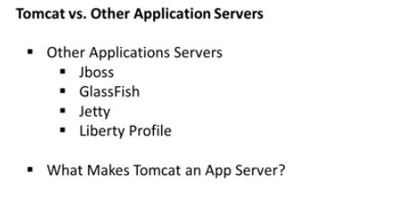

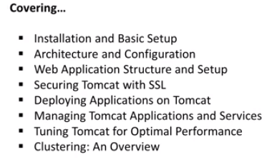

## Lecture: Tomcat vs. Other Application Servers

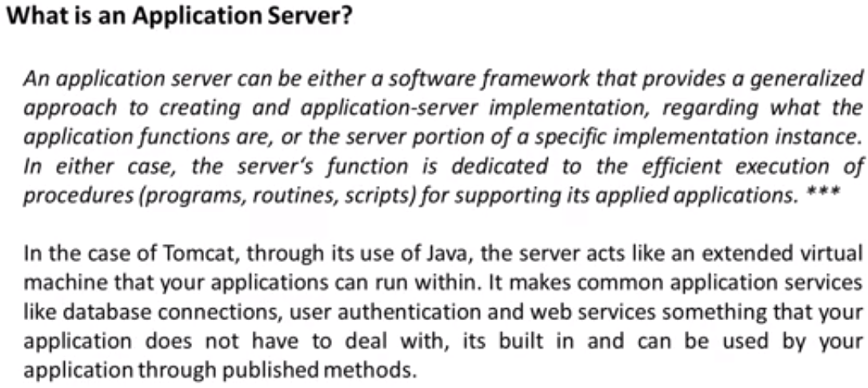

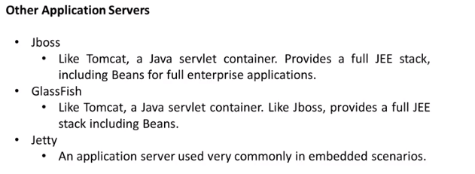

Glassfish is Oracle’s application server.

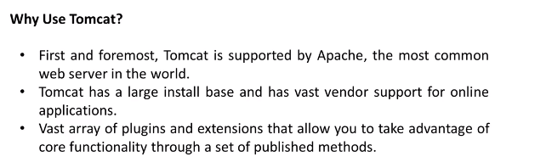

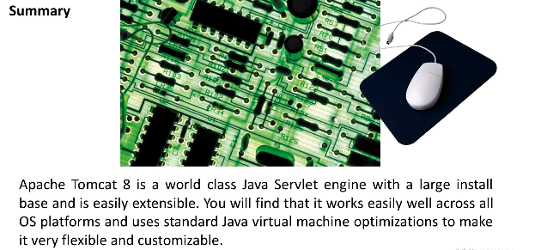

## Lecture: Apache Tomcat 7 vs 8 - Major Differences

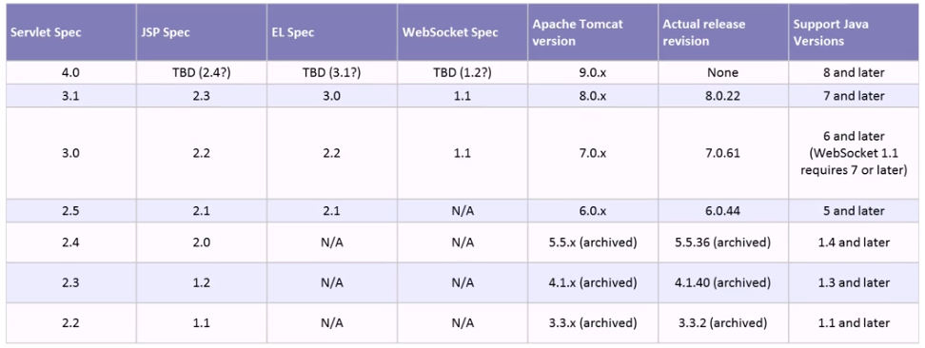

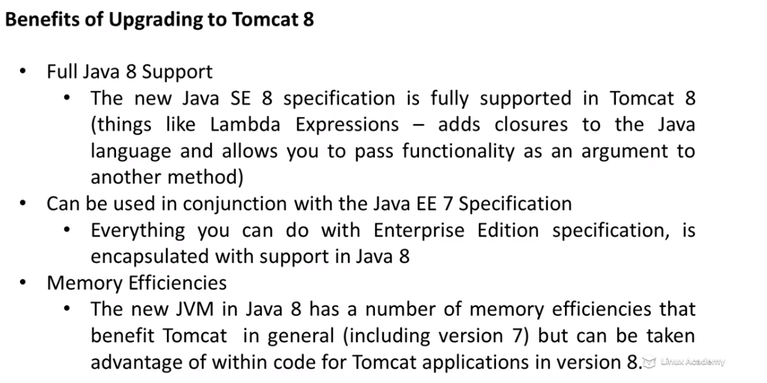

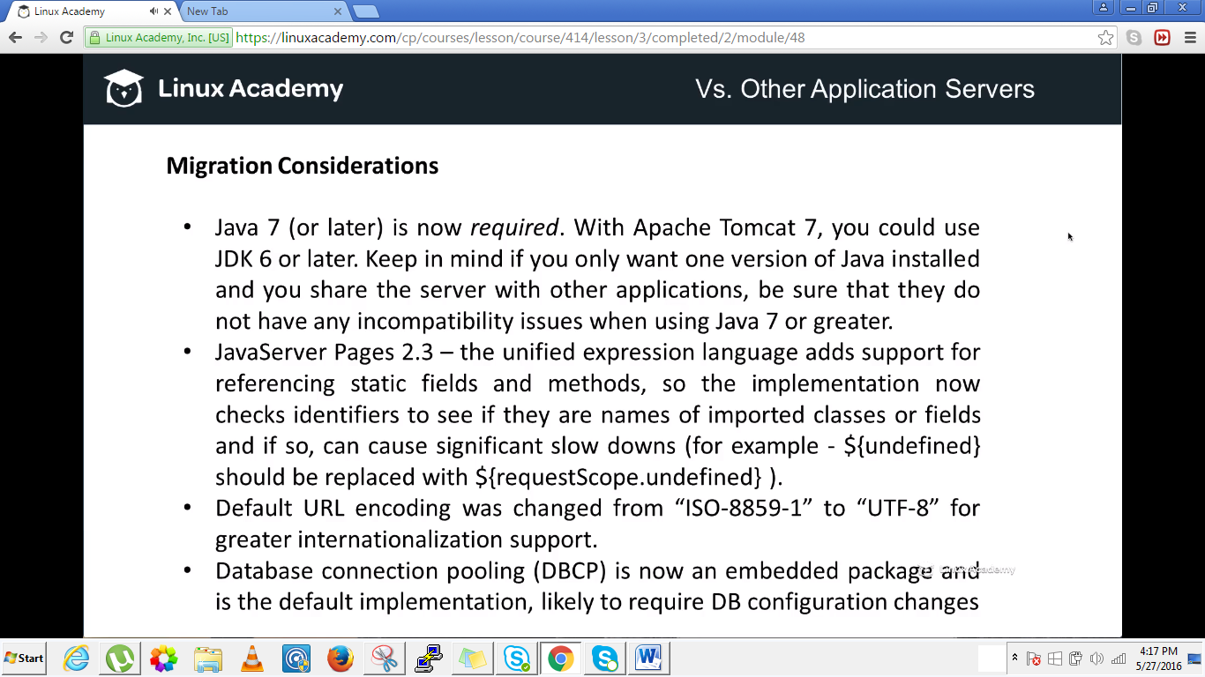

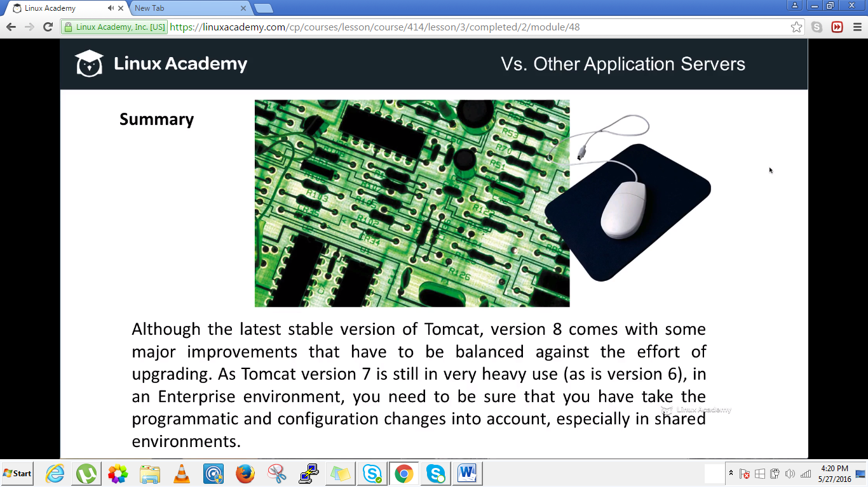

### Installation and Configuration

## Lecture: Oracle Java 8 Installation and Setup

In order for apache tomcat 8 application server to run we need to have a version of JAVA installed which would run the apache tomcat8.

Go to oracle website and download JDK version 8.

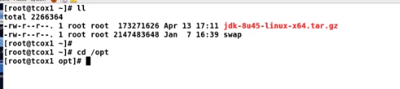

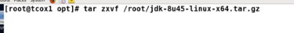

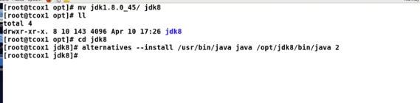

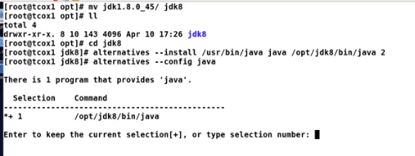

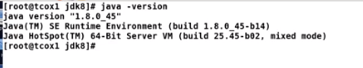

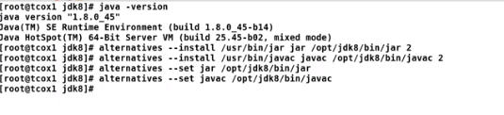

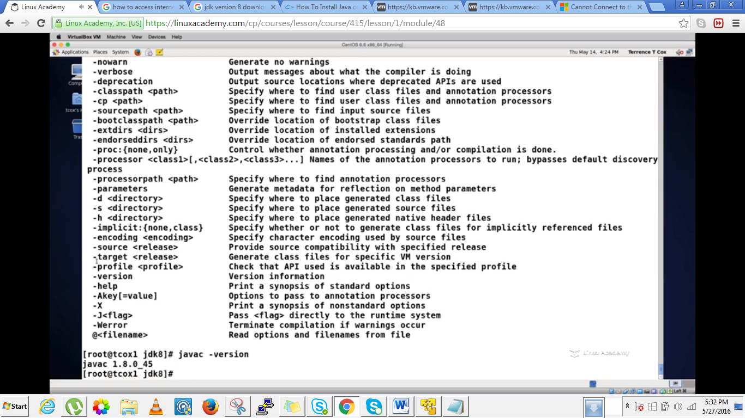

## Lecture: Apache Tomcat 8 Installation

Now that Java is installed and configured, let's pull down, extract and install the latest Apache Tomcat 8 stable version. Once installed, we will run and test the application server to be sure its all done correctly.

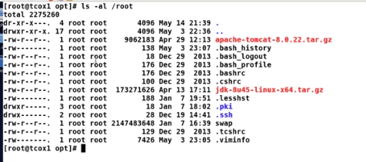



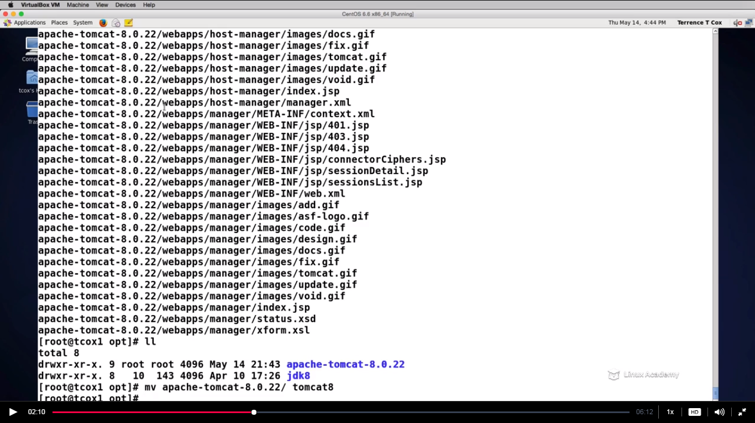

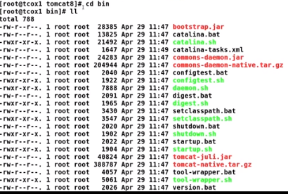

Till now tomcat is not running.we need to start the tomcat.In order to do this we need to export an environment.

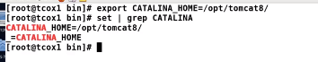

We did that because this environment Is looked thoroughout the configuration for tomcat.

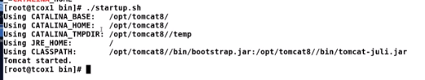

**The tomcat is started. In order to verify**

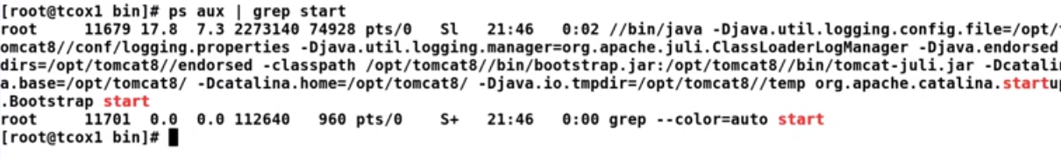

If we do telnet and we would find something is listenining port 8080

## Lecture: Apache Tomcat 8 Environment Setup

Now that our application server is installed and running, we are going to take a look at how to set up our global environment for it to run correctly.

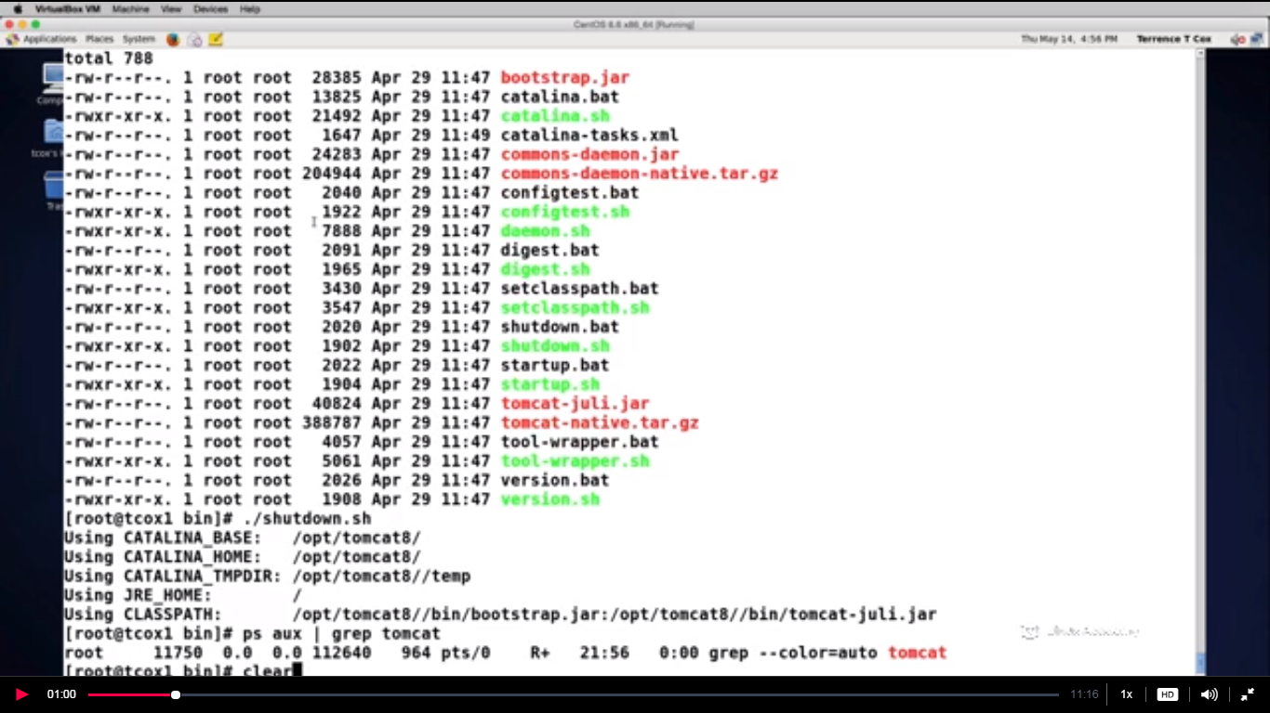

In the last lecture we need to export the environment variable called catina_home in order to start the apache tomcat to startup.

Now what we want to do is to decide how we want to configure some environment varialble that are important for Apache Tomcat to run.Now what we will do is we would make environment variable available globally or say universally and can be exported globally.

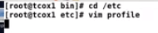

Put the entries

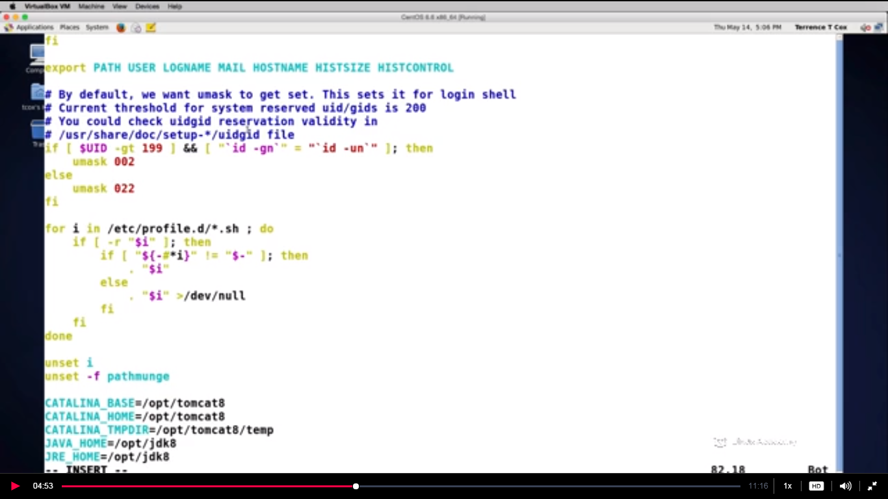

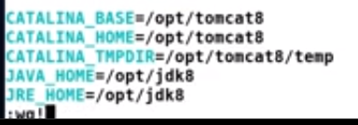

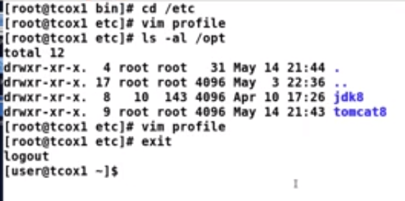

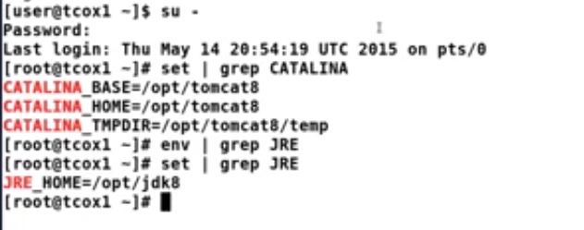

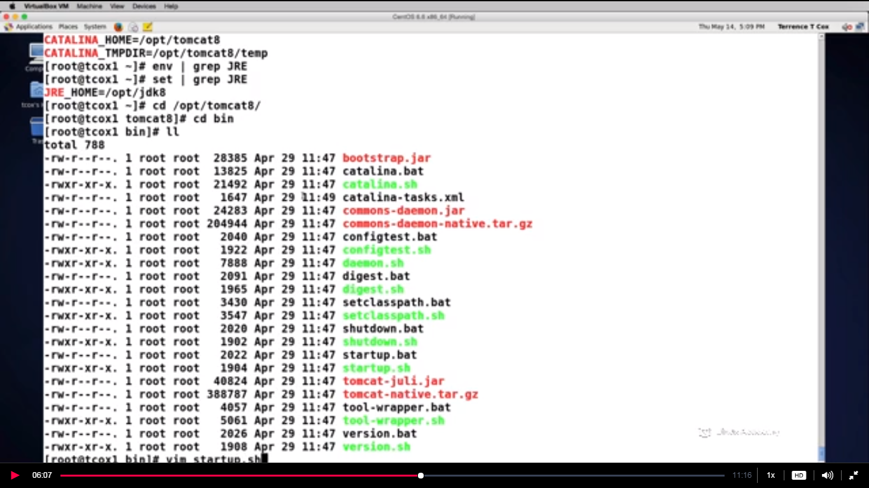

If we vi the startup.sh then we find that the script which is run inside is the catalina.sh as

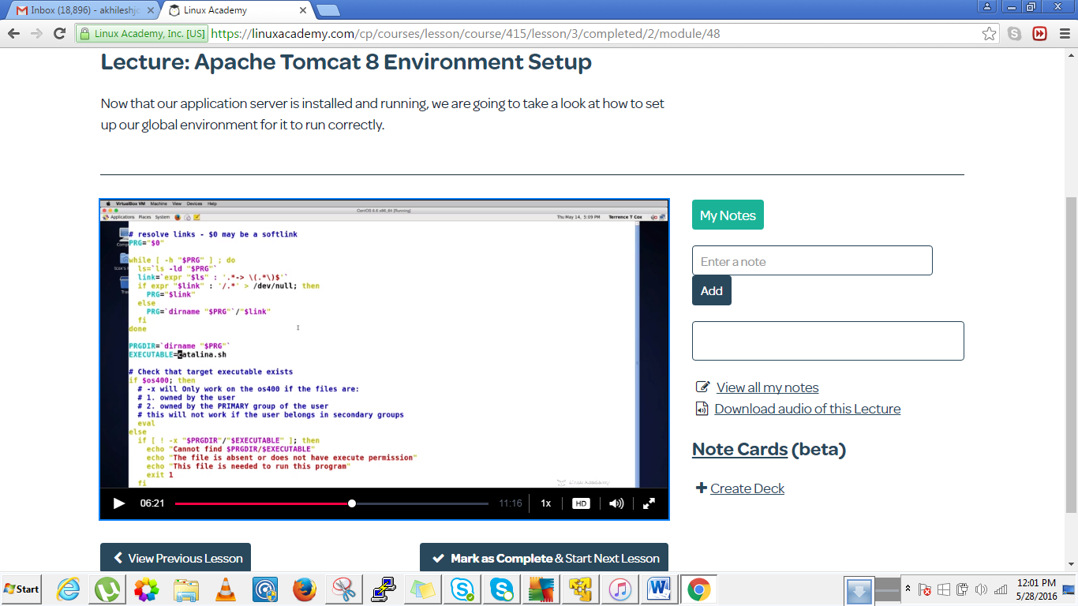

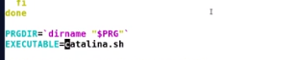

Now lets check catalina_sh. Lets vim catalina_sh

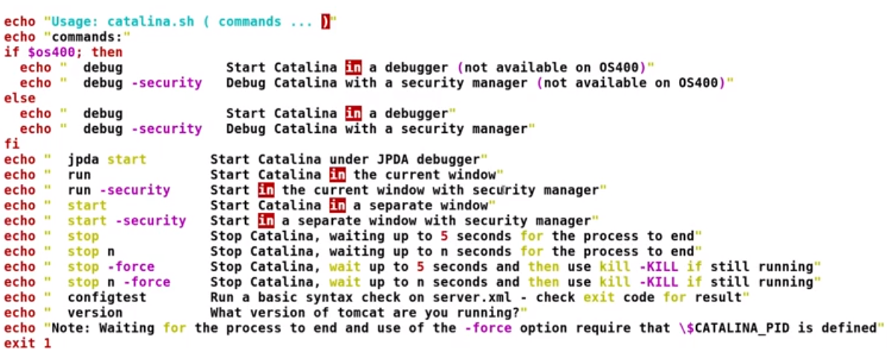

In the bottom we have these many options which we can do.Above we can see that.

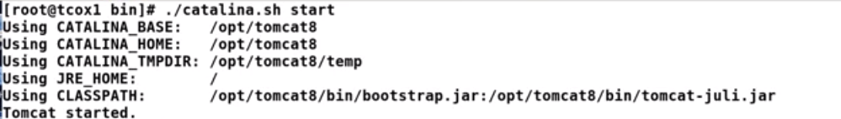

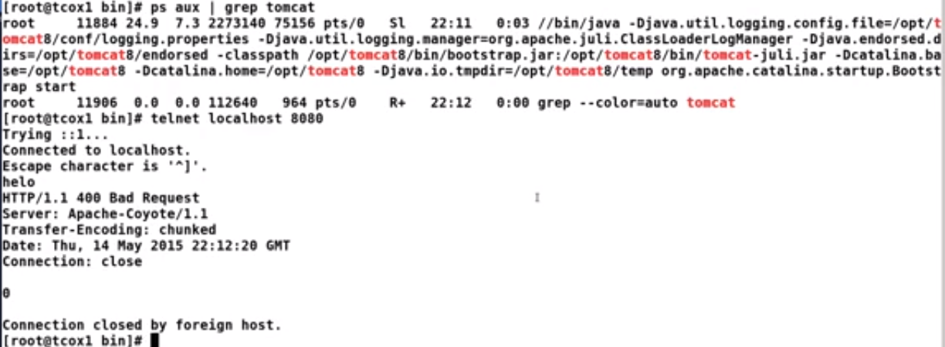

The same command can be used to stop tomcat as the start command.sometimes the tomcat doesn’t get stopped evern after running the command ./catalina.sh stop then we can force stop as

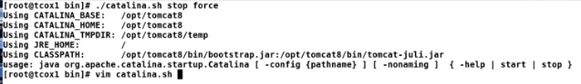

And you can see if you vim catalina.sh and then go to the bottom ,you would see if we do stop –force it would wait for 5 sec ond and will then use the kill command rather then just stopping.

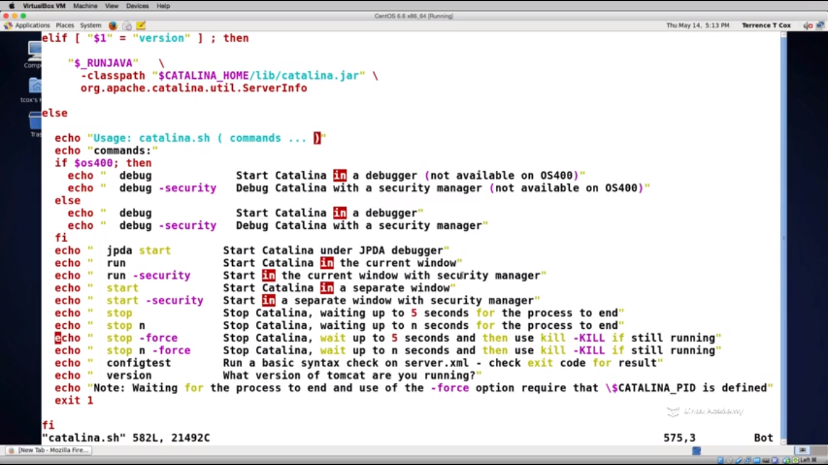

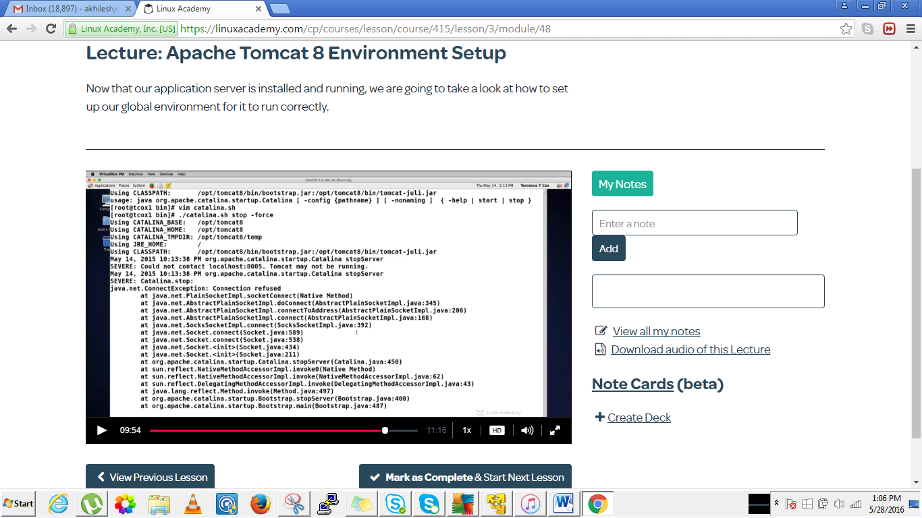

Its already stopped then we need to start it again then we will stop it forcefully

First start again and then do

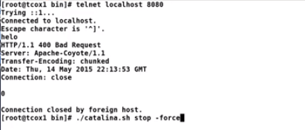

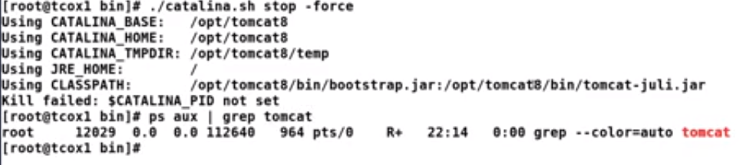

Later we will see the catalina.sh is the file where we are going to make the configuration changes for directories and options and we will see the xml file for database pulling changes and JAVA memory optimizations changes.

## Lecture: Customizing the Java Virtual Machine

We continue building on our exploration of the application server instance by exploring where the java virtual machine can be customized in our specific environment.

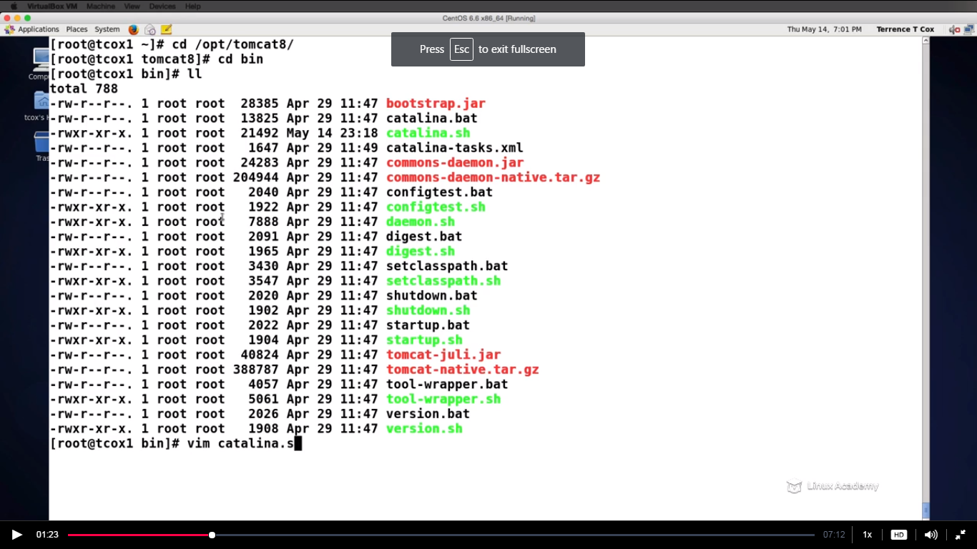

In the bin directory we have the catalina.sh which is the main driving script in terms of managing ,stoping and starting the tomcat servi ce

If we want to increase or decrease the size of the JVM while starting we can do here by putting xms120m ie 120MB.Also we can set min sizw as xms256m.

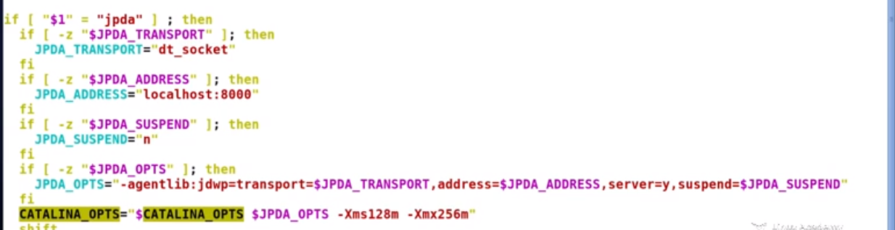

Start tomcat after the changes are made

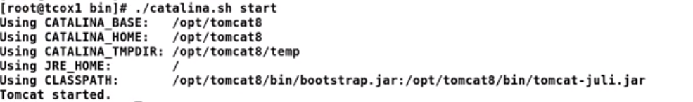

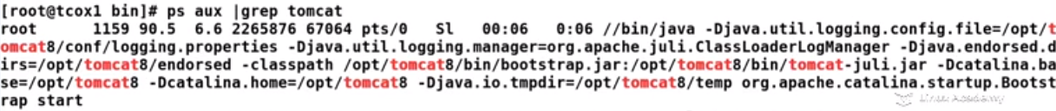

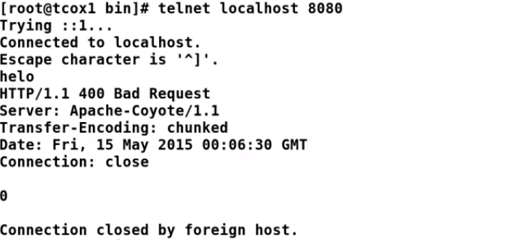

## Lecture: Tomcat File and Directory Architecture

Since we have things running and have taken some basic configuration steps to understand our instance, let's take a step back and take a deeper look at the file and directory structure and what each one offers our installation.

Till now we have done some configured environment varialbles,we have also looked upon some memory optimizations in the catalina.sh file and we have started and stopped our service with those environment variables at local level and global level.

Now lets look the important directories and what they contain

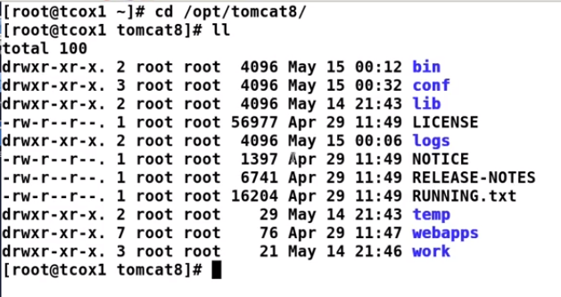

Already we know that the /bin directory contains the application shell scripts , everything­ which is responsible for managing the instance of our apache tomcat engine.

We have the conf directory which contains the configuration for the server,the web,the tomcat instances as well as policies and properties that are primarily responsible for the configuration of our tomcat instance.

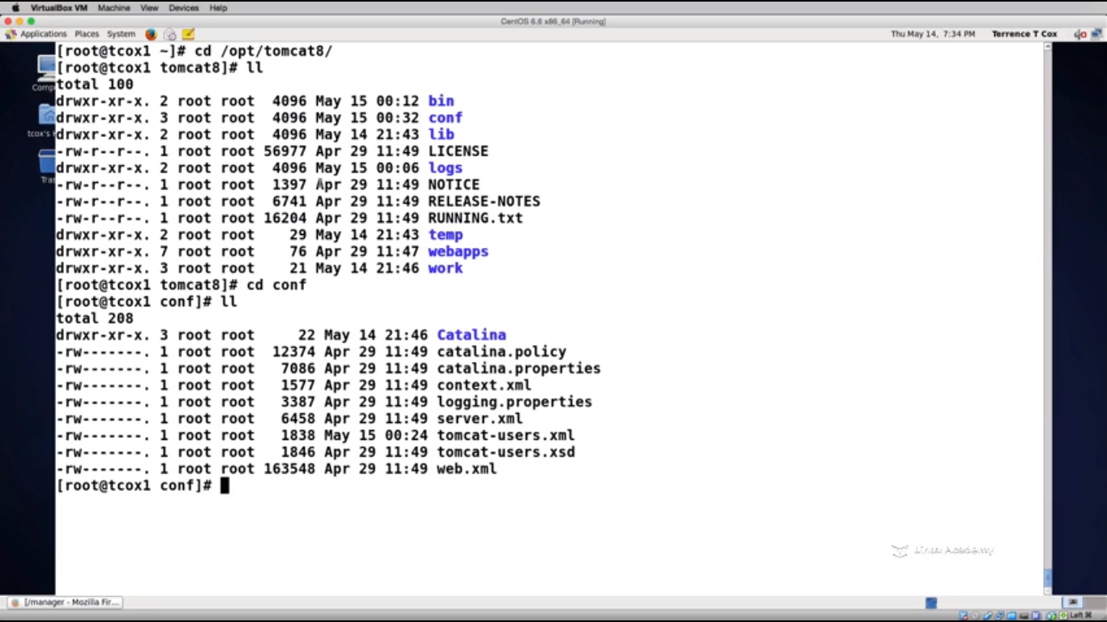

The lib directory contains the libraries that are available for the tomcat

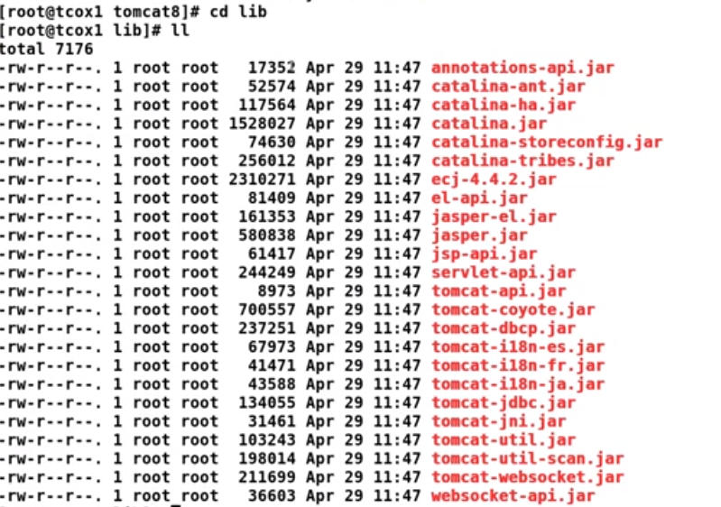

The logs directory has the logs for your apache tomcat instance .**Anything related to the web GUI ,where you may and may not able to login as you don’t have the access the instance ,these all errors are here in the hotname manager**.The local host log has the information about the host on which the apache tomcat is running upon .

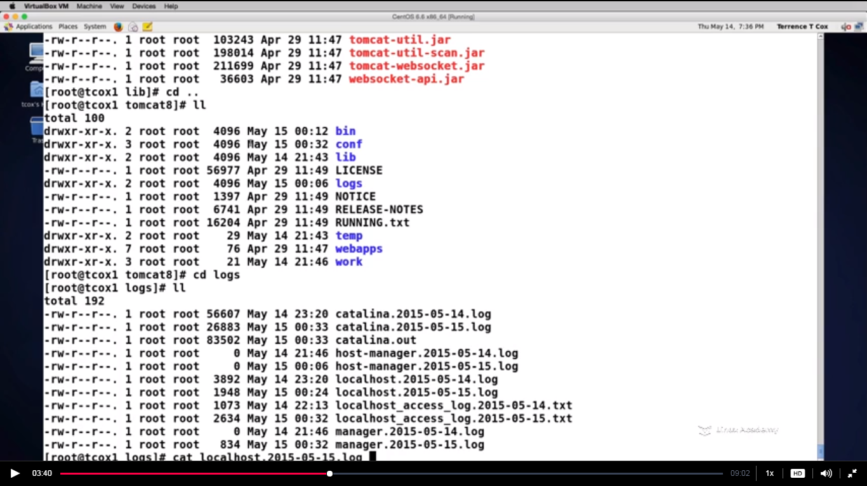

Then is the manager.out which tells us about the management application whether we are stopping or starting the application context.

**The catalina is the primary logging directory for the apache tomcat instance**. **Its here where you will find your application and user errors.**

**If we want to see the exception then do**

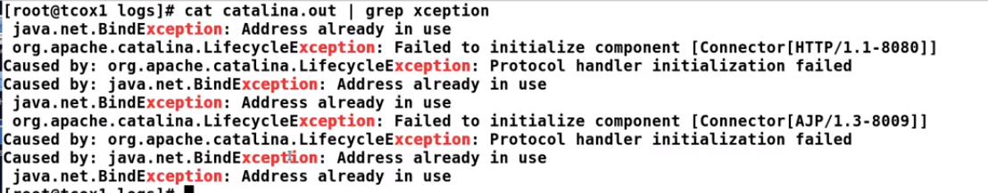

The temp directory contains objects that are cached out to disk while the engine is running.These can be java objects that are cached from memory.

The webapps directory is the directory where your servlet context would be or say where your applications would be.

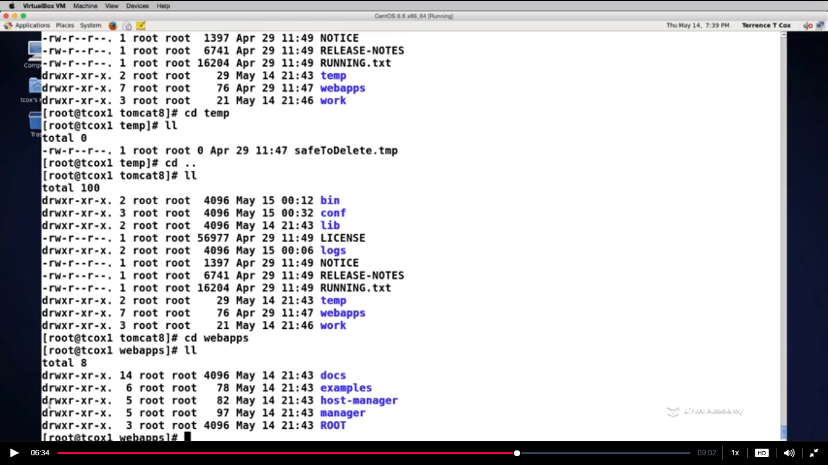

Every directory corresponds with an application context.If we go here

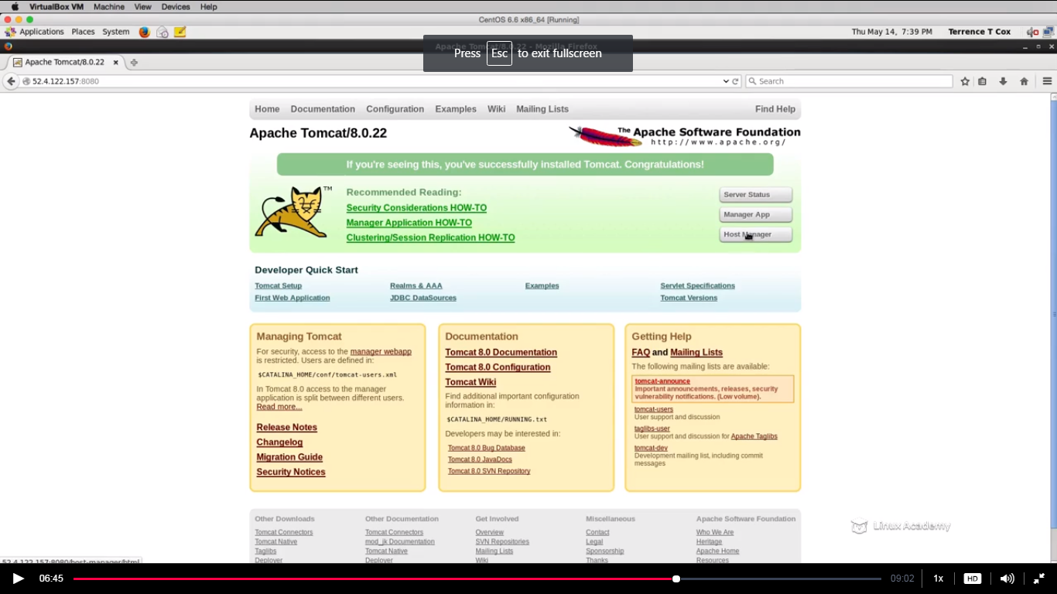

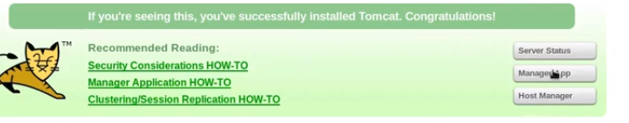

We see the server status ,manager app and host manager and if we go to the manager aap

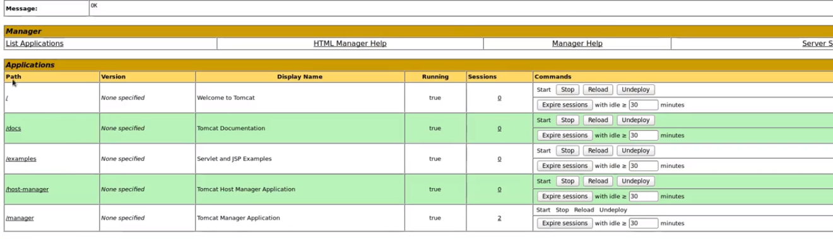

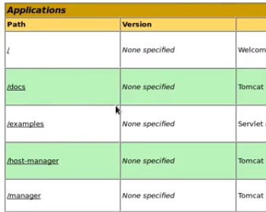

we see the application context i.e docs,examples,host-manager,manager etc and if we come back we see the same directories as

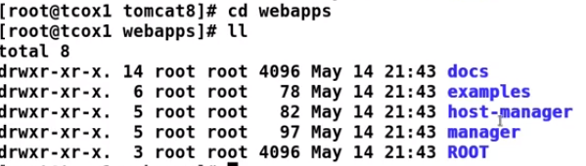

The Root is the special directory and contains the war file.

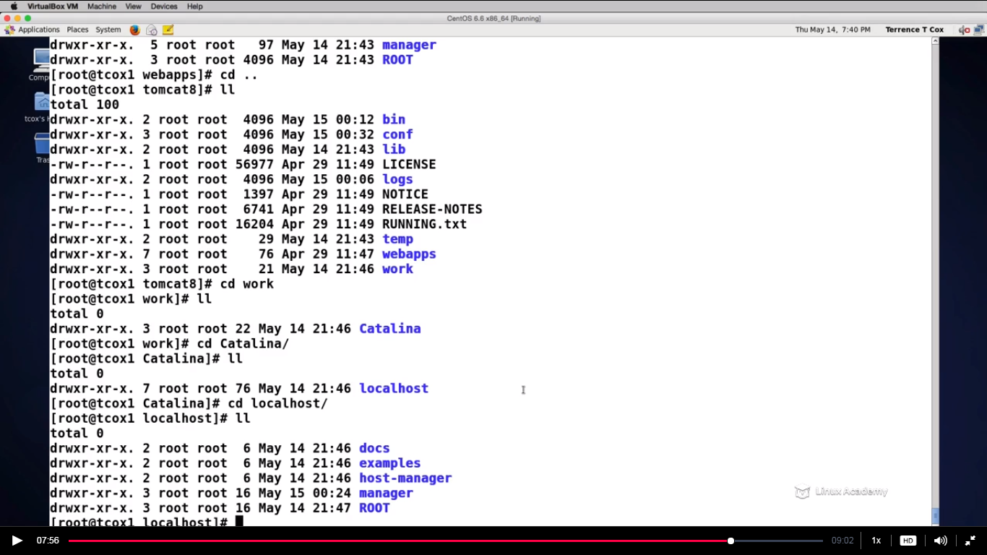

Now going back the directories we have the work directory which has the same application context and it is built as a part of application deployment process.

### Deploying Applications and Managing Tomcat

## Lecture: Security and User Accounts

In managing our Apache Tomcat instance, we need to understand the security model. We will talk about the roles and access for users on our system and how to define them in our XML configuration file.

Everything which is important is defined here in the xml files and everything which is dealing with our tomcat users is defined inside the tomcat-users-xml as

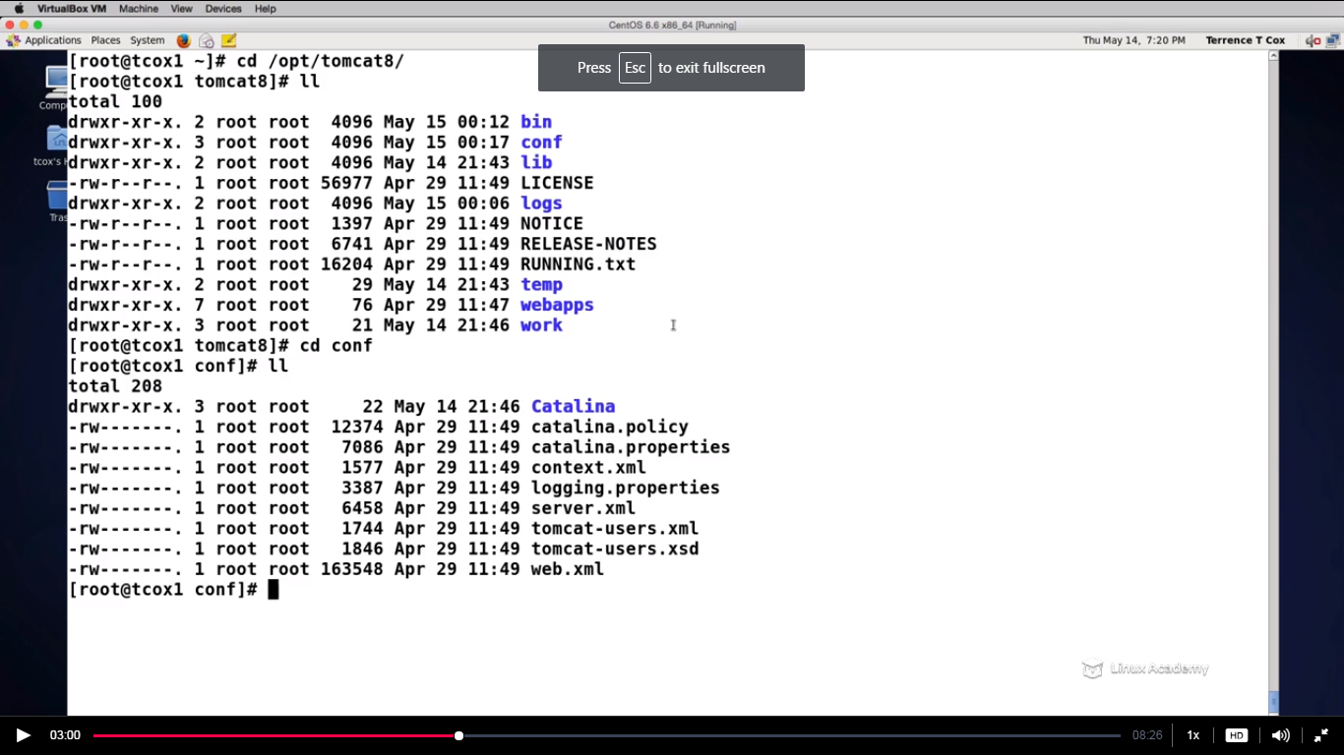

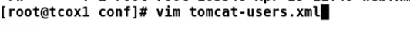

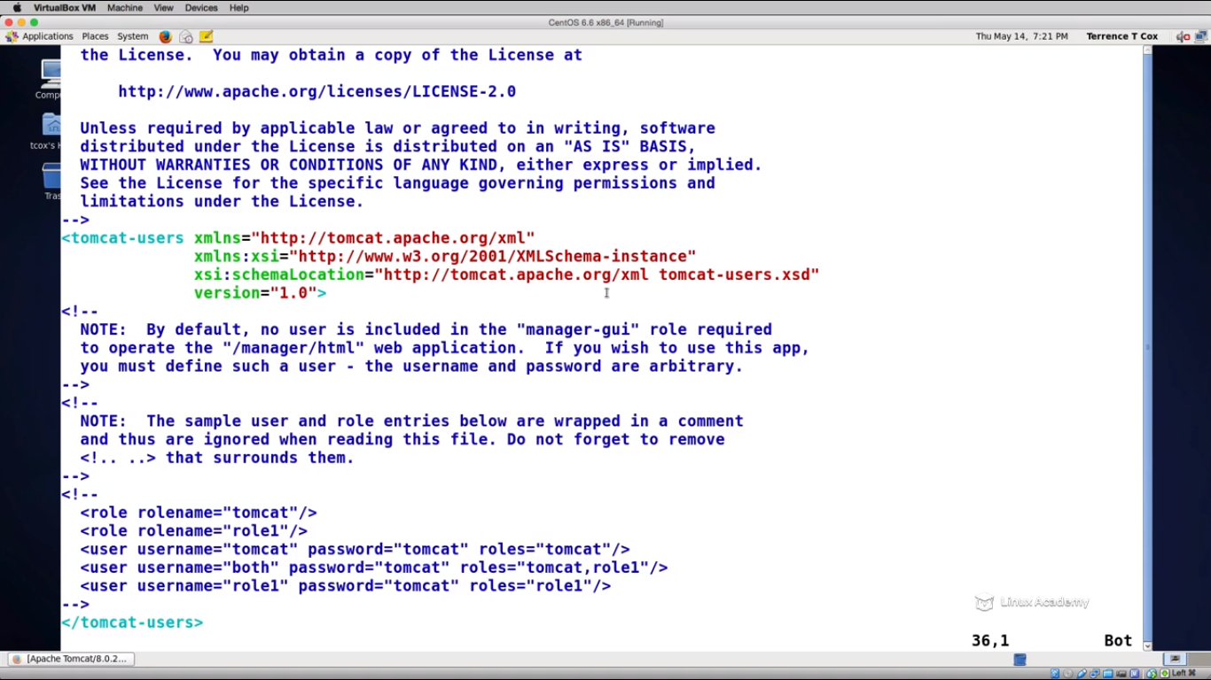

Here is the area(tomcat users) that is commented by default. And while accessing the manager apps status in the tomcat web-GUI it is asking for the username and password as

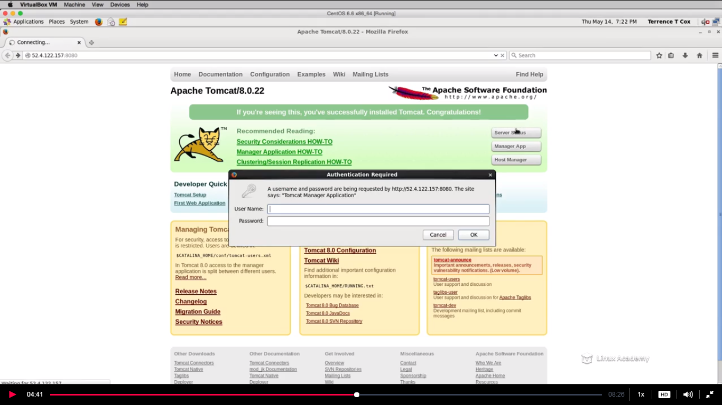

So when we comment the users area in the tomcat-users_xml there is already a role-1 created and we can try using that role’s credential once to check if it works to access the manager status

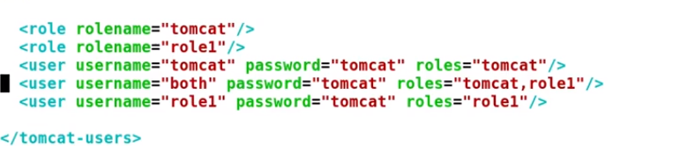

By giving the username and password as tomcat lets try

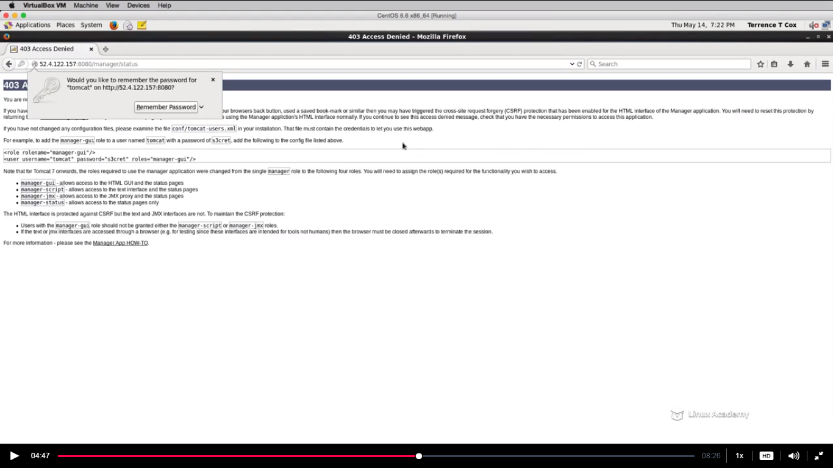

And we get the error that means that role has no permission to access the manager apps so lets create one role as



And then we have to add an actual user that can exist in this above role as



And it must look like this

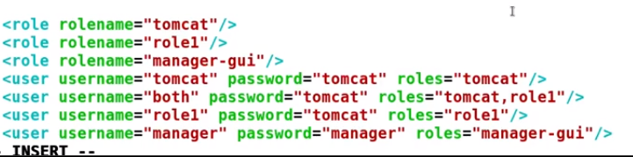

And after making these changes we need to restart the tomcat

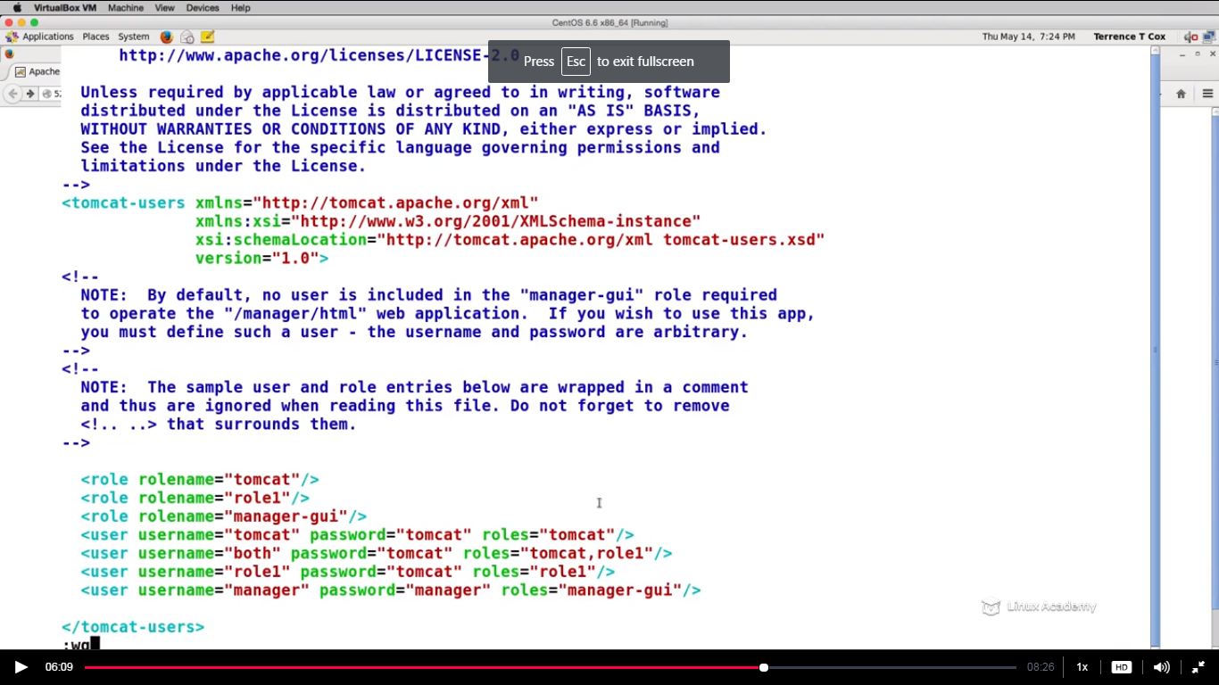

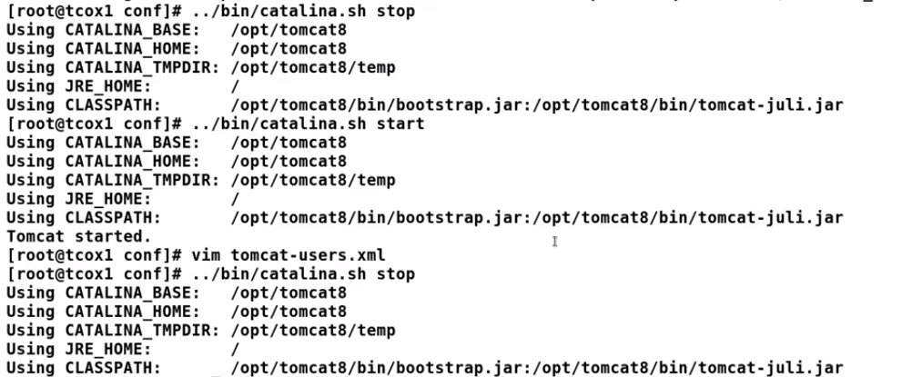

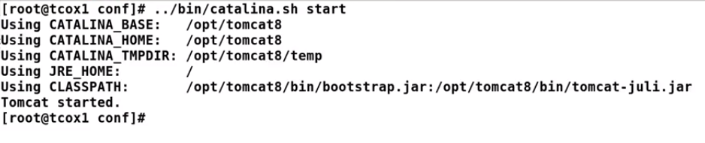

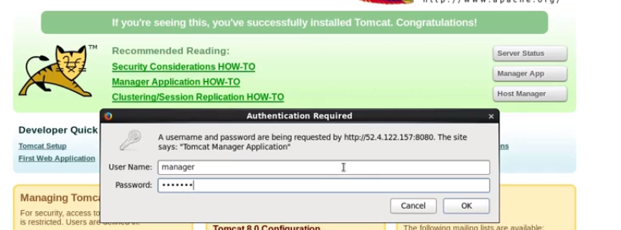

We give username and password as manager and

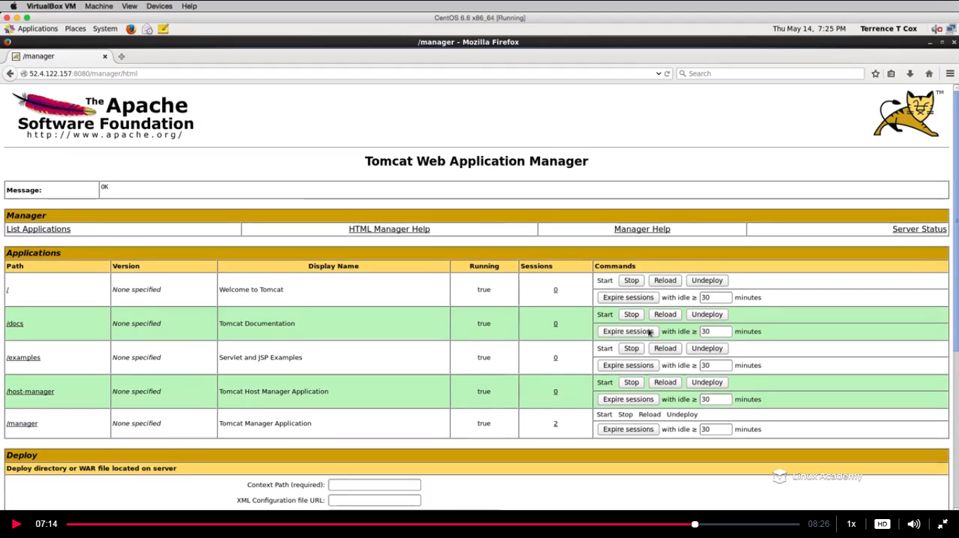

We are able to access.

**So we leart how to add secure users to manage your apache tomcat servlet from the web-gui.**

## Lecture: Deploying Web Applications

One of the primary uses for an adminstrator, is the deployment of applications (servlets or contexts) on a running application server instance. In this video, we will show how to do it at the command line on the server as well as using the management GUI.

till now we have seen the default applications that came bundled with the basic apache install and these applications on which your apache engine is running are called context or servlets.

There are a lot of ways to deploy an application to apache but the important thing is from where you are deploying .IF you are deploying with the command line then you take what is called as a war file. The war file is a java application that has a very specific format so that the tomcat knows how to deploy it within a structure.

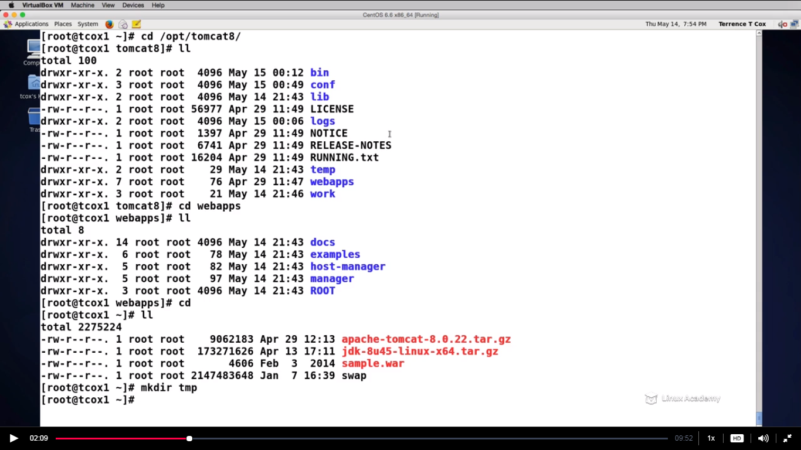

So we have downloaded a sample war file from the tomcat website and we create a tmp folder.Now lets extract it within this folder and we will se that we have a directory structure as was with the jar file.

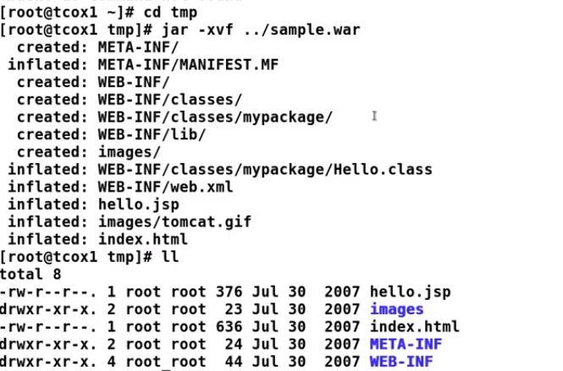

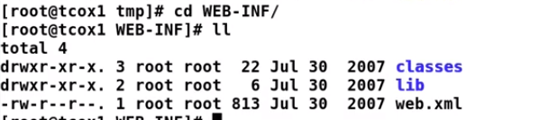

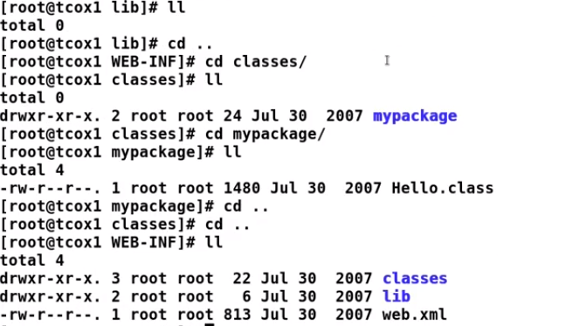

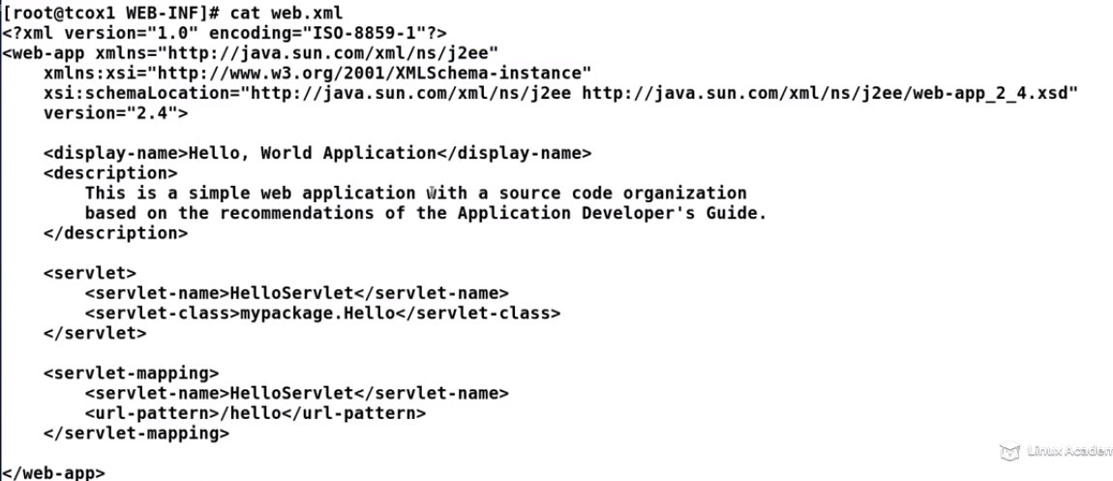

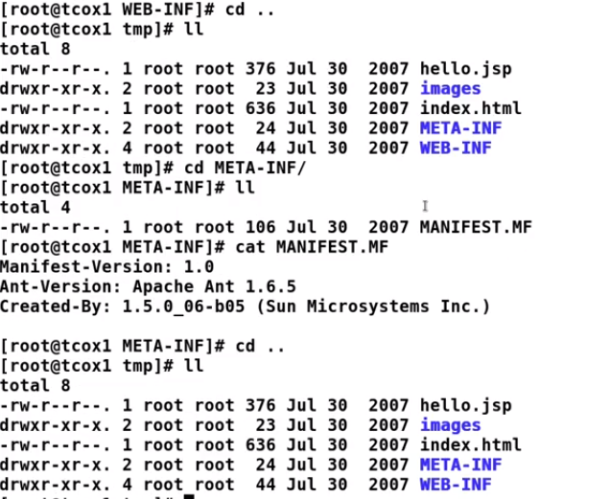

If we see our opt/tomcat8 folder as

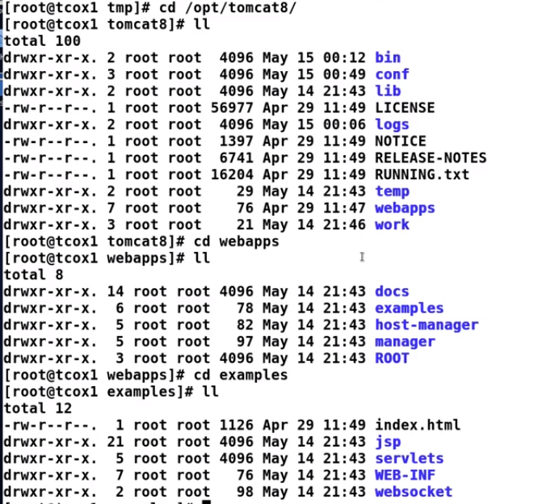

We see the same structure as that is inside the war file.

So the XML file is the file which your apache instance will look for.

**There are two ways to deploy an application. Neither one is good or bad. It depends which access you have command line or GUI. If you are deploying with the command line the simplest way to deploy is to drop the war file to the webapps directory and restart the tomcat.**

So lets deploy an application. First stop tomcat as

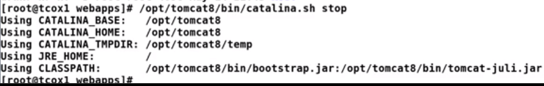

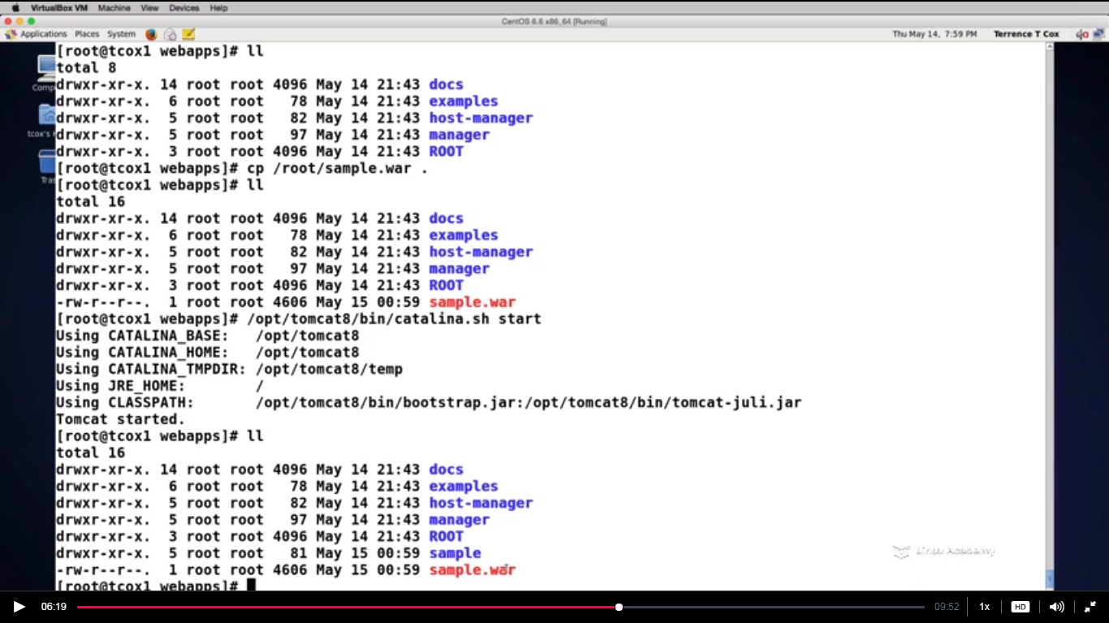

**WE copied the sample.war file from the /root and pasted in the webapps directory and restarted the tomcat. And then we see a sample folder which has the expanded version of the sample.war.**

**Now lets get back to the console i.e GUI and under the manager app we would be able to see a context i.e /sample.**

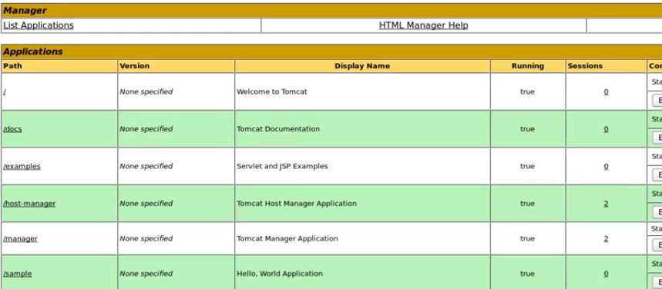

We can access the content of the sample either by clicking on it or by adding a /sample on the url. And below is what we get after clicking on the /sample.

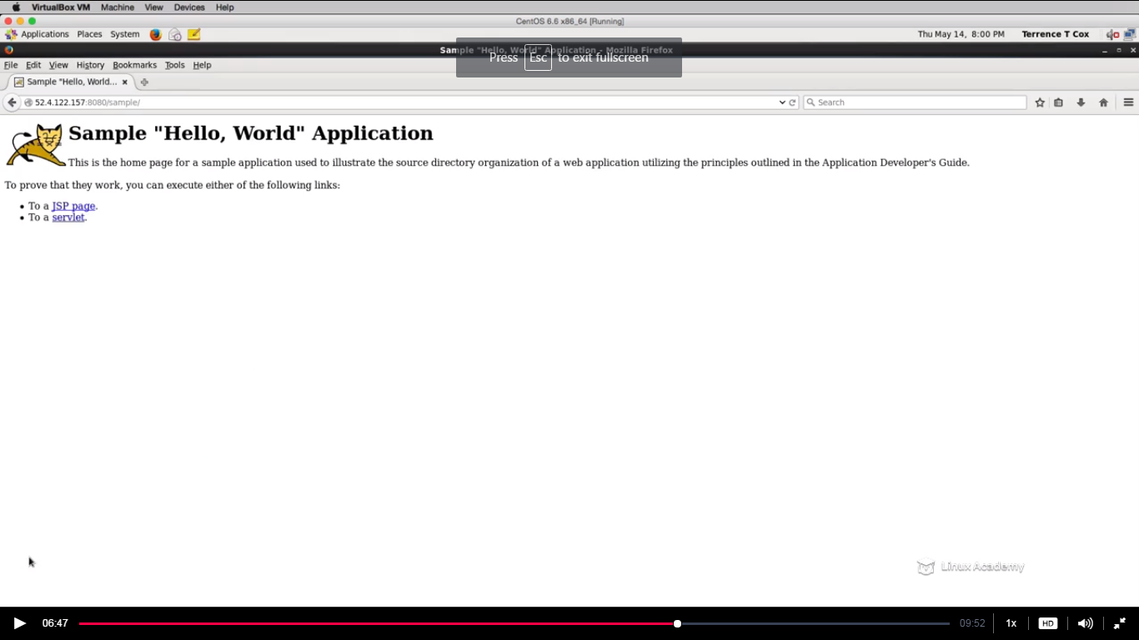

So this context is deployed to this application manager engine. So I can stop specific context if we want lets say if we have the applications that are sharing the engine space . I can stop start any context and completely undeploy it as well.

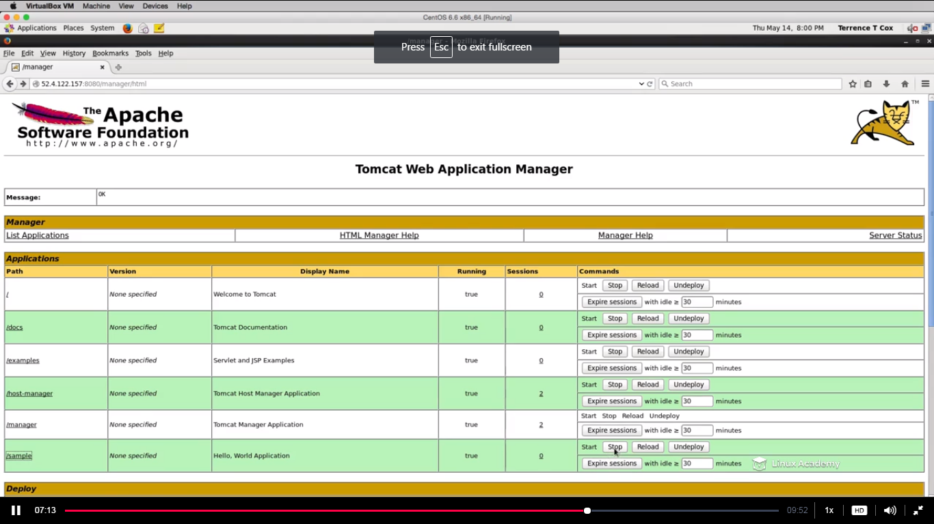

If I undeploy the sample context then I wont be seeing the /sample inside the webapps as

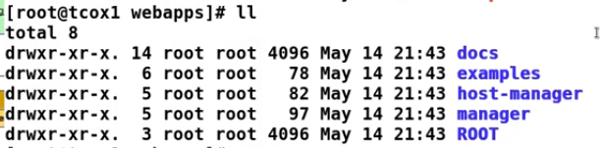

Before undeploy

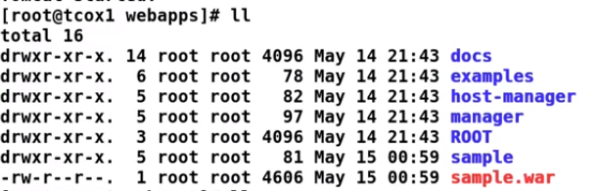

We even don’t require the tomcat to be restarted when we undeploy or deploy from the console.

So there is another way to deploy from the GUI which don’t require the tomcat to be restarted as

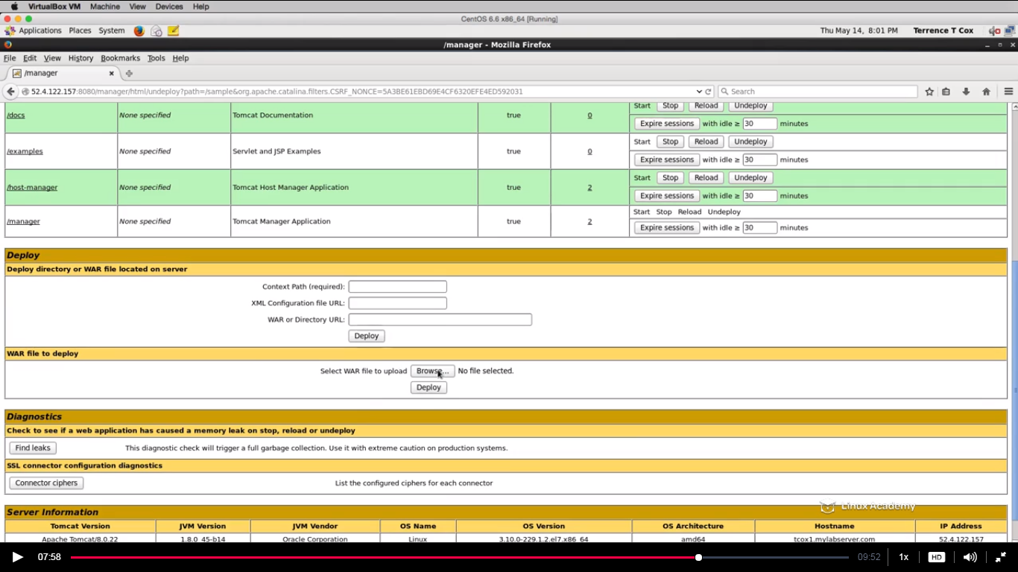

We need to browse the .war file

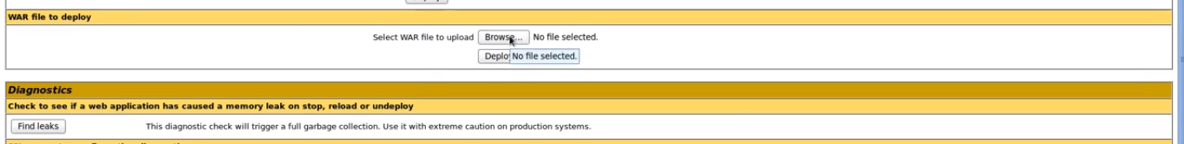

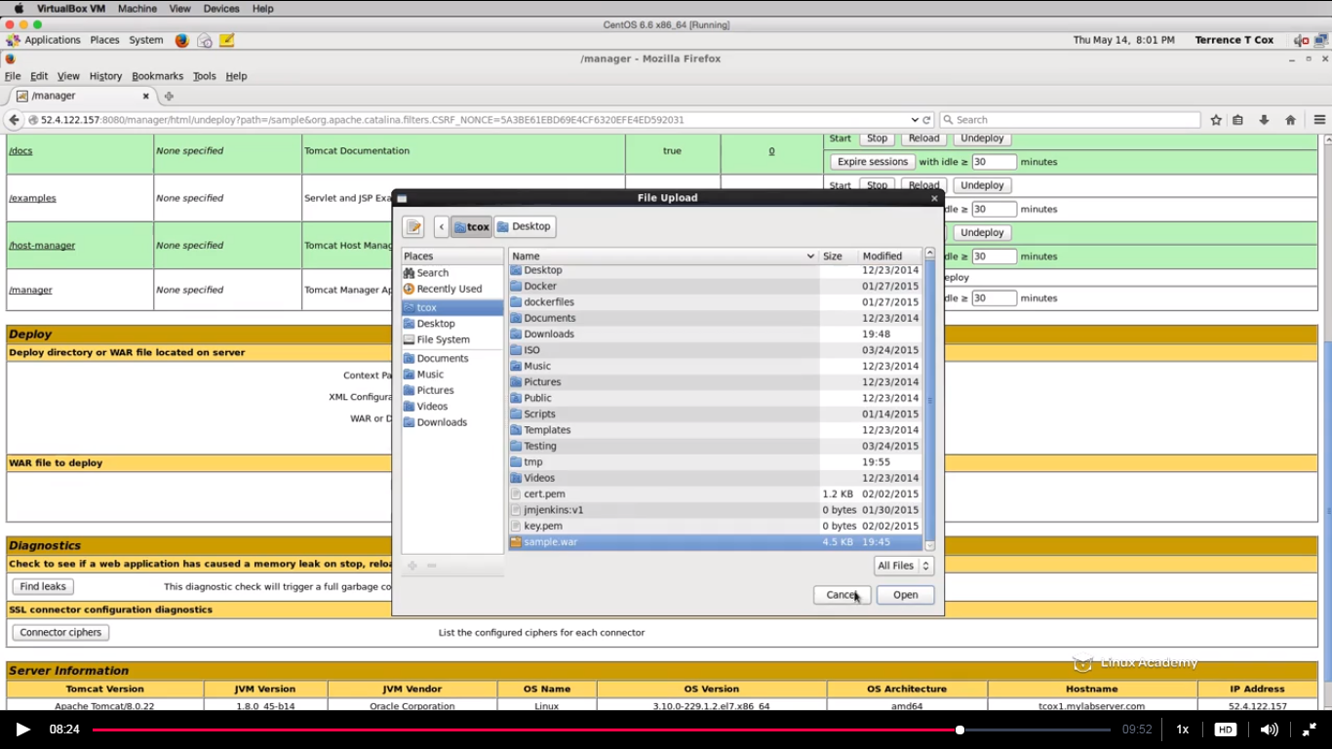



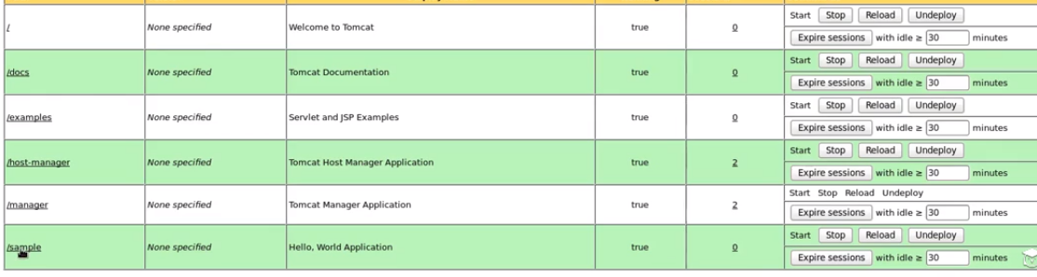

It is now deployed. We can see the /sample directory as well.

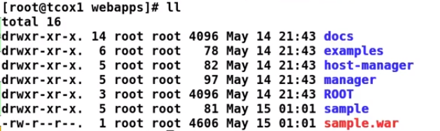

So these are two common ways to deploy an application.There is a third way too which we will see in the advanced lecture which gives more flexibility.

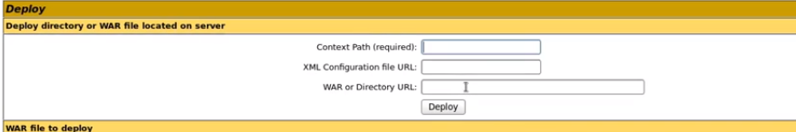

## Lecture: Managing Applications

In this video we will talk about how to manage our various application contexts on a running server. We will use both the GUI and command line to move things around and notify the running instance of changes.

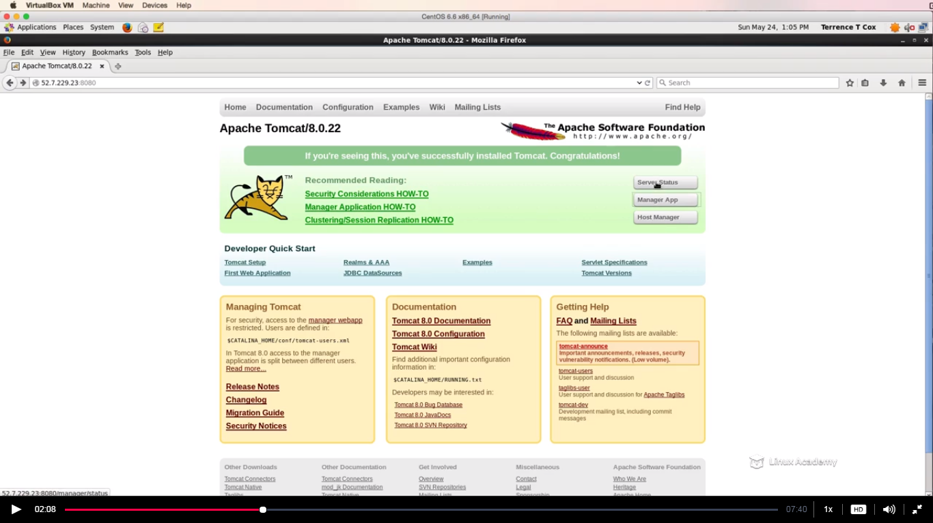

The server status gives us the information like the apache tomcat version

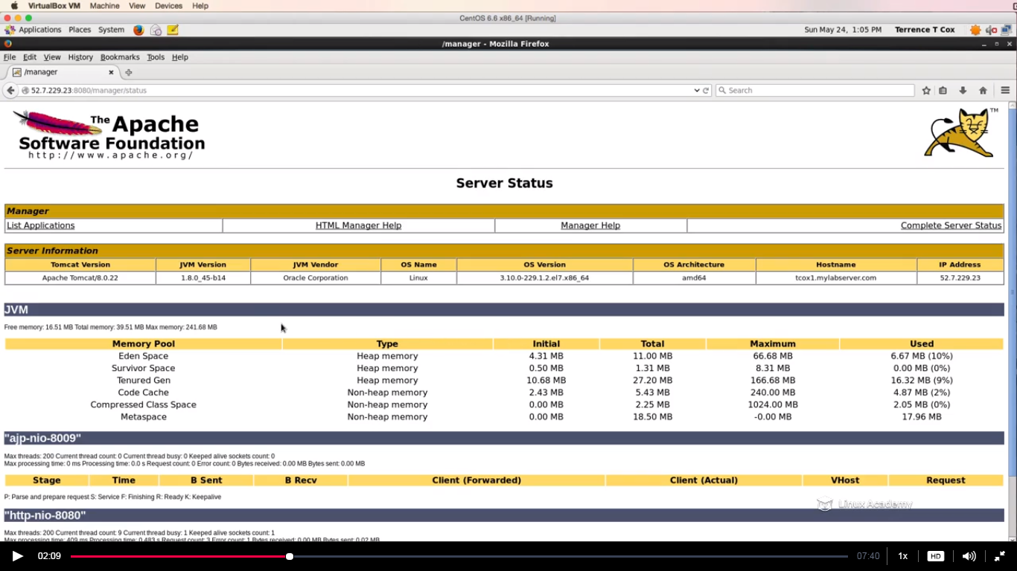

There is one thing you can do in addition to the GUI , you can connect to the tomcat instance remotely and shut it down from there as well with a simple command.

By default apache has a shutdown port that is 8005.

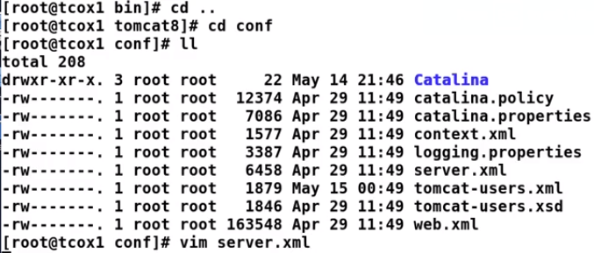

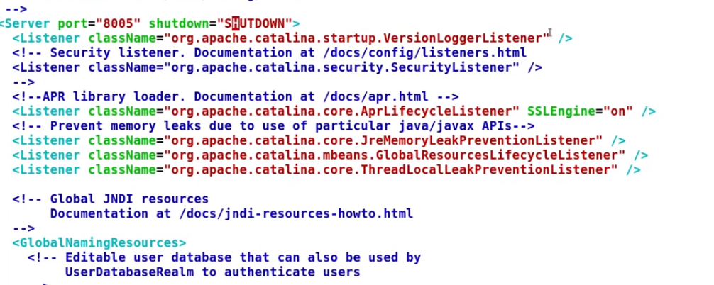

So we can see the port 8005 mentioned here and it says shutdown.So what we can do in order to shut down apache tomcat is telnet to port 8005 and write SHUTDOWN and if you do ps aux |grep tomcat ,you see the tomcat is stopped

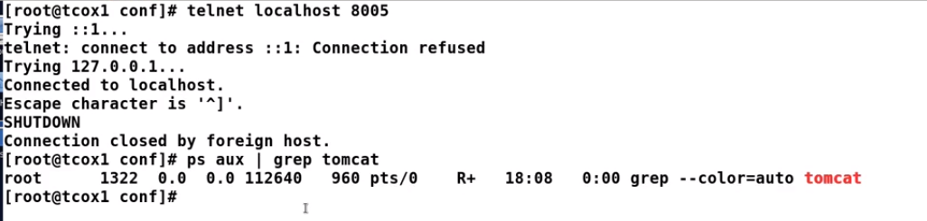

So here is a problem if many people knows this default behavior and if they do a shutdown with port 8005 after giving a SHUTDOWN. So in order to manage the tomcat application what we need to do is to edit the XML file as

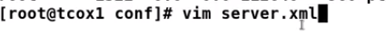



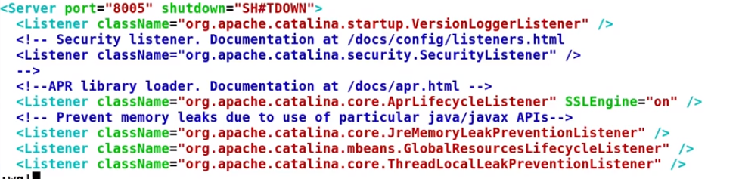

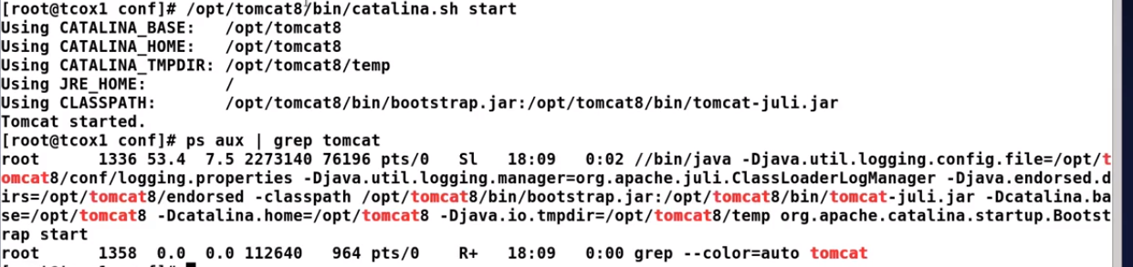

So now if I try to telnet and give a SHUTDOWN command it will disconnect me and tomcat would still be running as

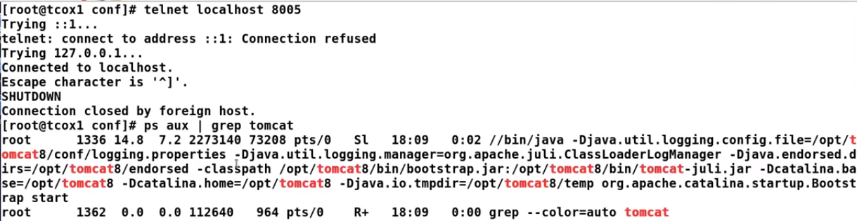

And if I do telnet followed but SH#TDOWN as

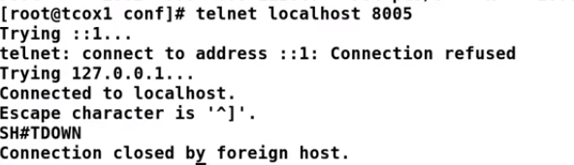



Now Im able to shutdown it.

## Lecture: Connection Proxy

Since Tomcat typically listens on port 8080, rather than configure Tomcat on port 80 for normal HTTP requests, we can use Nginx to proxy those connections and rewrite the URLs. This video will show you how.

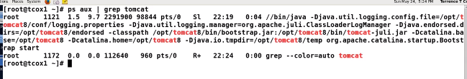

Tomcat is running.

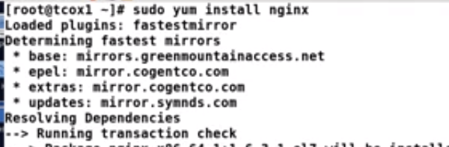

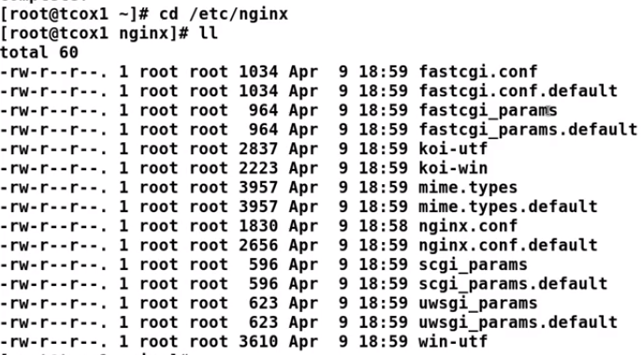

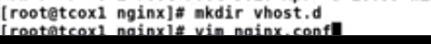

Put a new include statement.

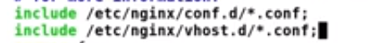

It will like the below after editing.

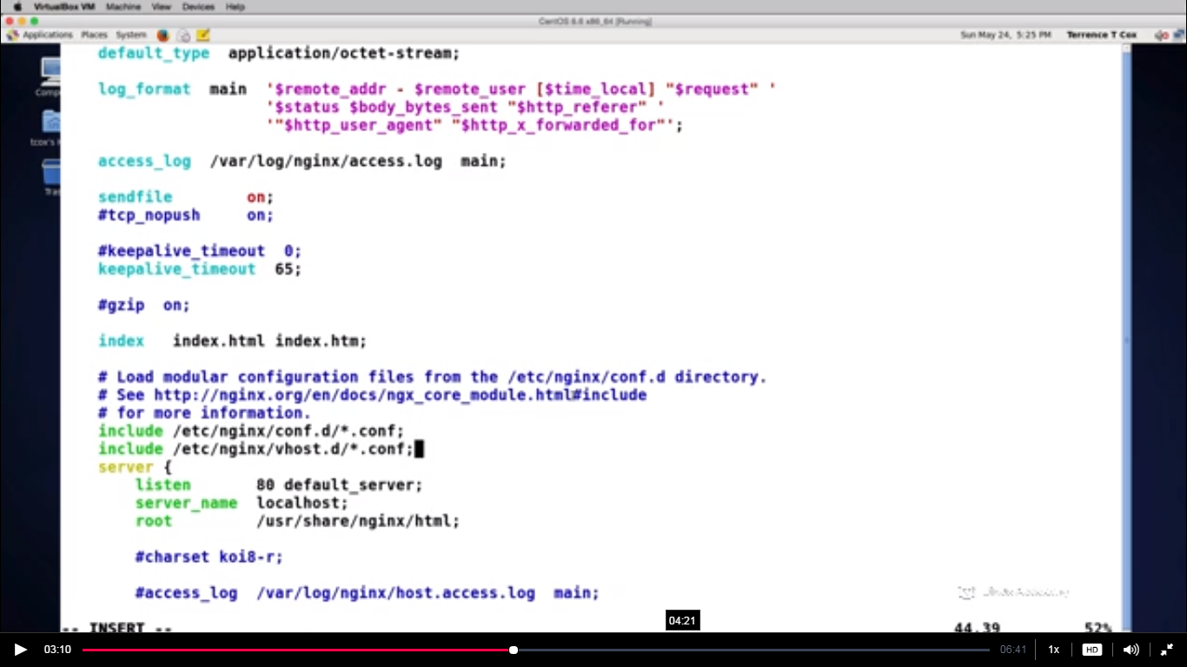

We have some default configuration which we don’t need now as all the configuration will be taken from the etc/nginx/vhost.d which we created so delete all the default configuration and it should now look like the below

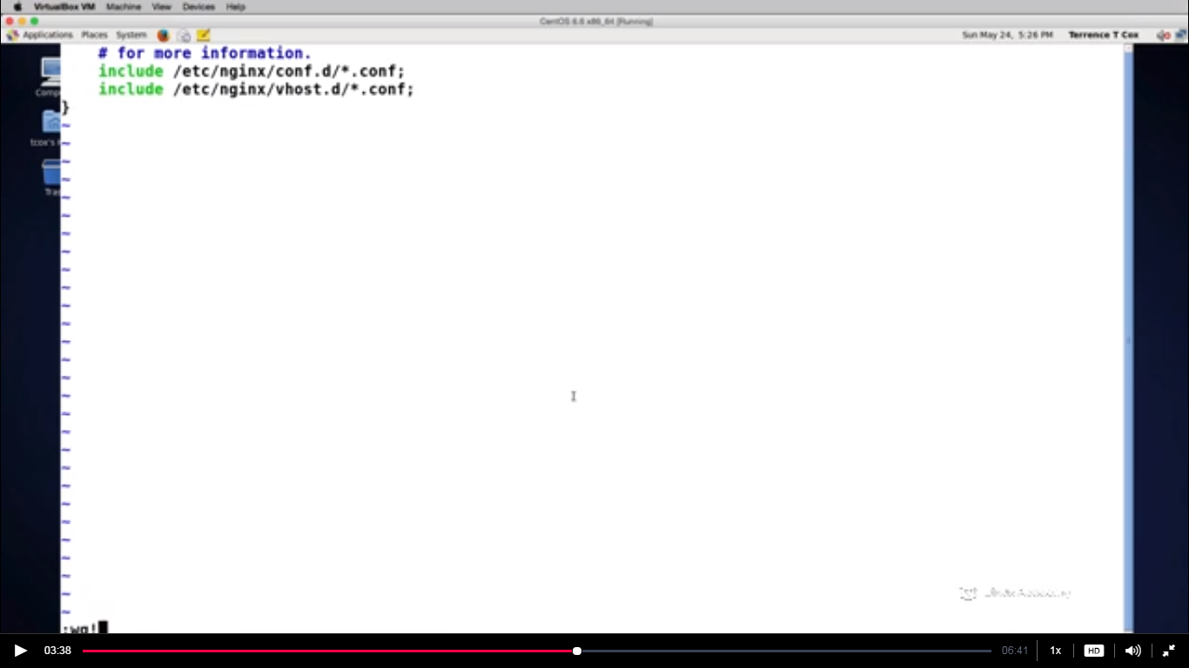

Comment the first include here i.e #include /etc/nginx/conf.d/*.conf

Now go to vhost.d and create a file called default.conf as



The default.conf would be the definition of how our server configuration is suppose to answer for the proxy server for our tomcat instance.

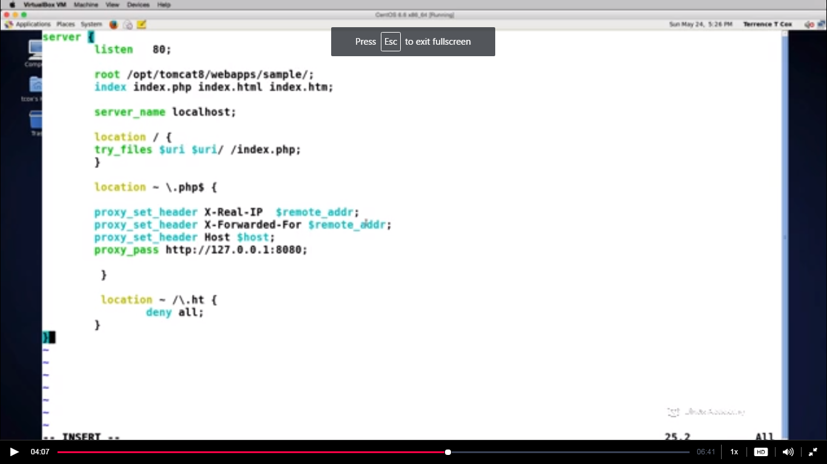

Write the above configuration into the default.com.



The advantage of using ngnx is that it will redirect to any port that we configure at the backend .We need to make one change i.e the port for apache and one change in our configuration file.

This was all proxying our http connections to the default port 8080 for apache tomcat. IF we go to the browser and type our ip we will get the below

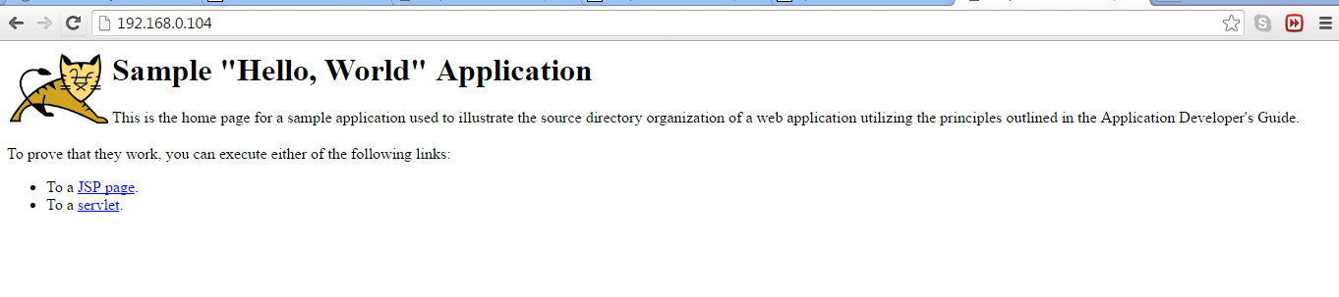

## Lecture: Basic Clustering

Tomcat can be used in a cluster to better handle load and concurrency. This video will introduce the concept and go over the configuration for clustering.

In this lecture we will see how easy it is to install multiple tomcat instances on the same server.Now if we have multiple servers that we need to do proxy and then load balance follow the steps

We need to install tomcat8 to a new instance as

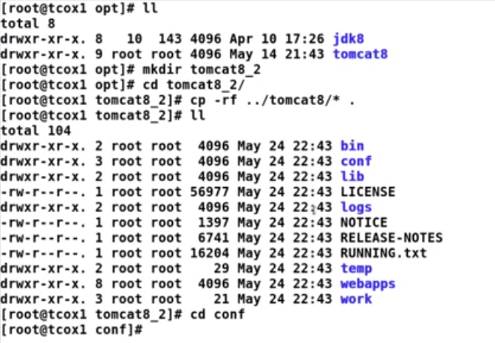

We have many ports so we need to make sure our ports don’t conflict.So if we go to server.xml file

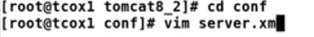

Make the shutdown port for new instance tomcat8_2 as 8006 as

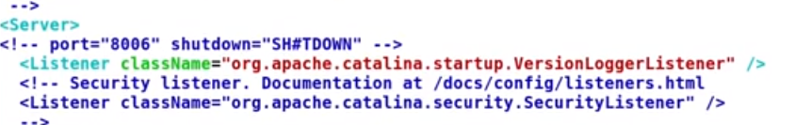

Also we see the port is already disabled for security purpose.

Also we need to make the changes in the connector port and redirect port,SSL port and AJP port.We need to increase these port by one.









These are the things which we need to do inorder to set a new apache tomcat instance.then start the tomcat. We can clearly see the tomcat8_2(new instance) has been started.

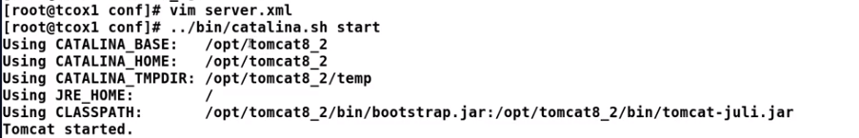

In order to check if we have two instances running lets do the below

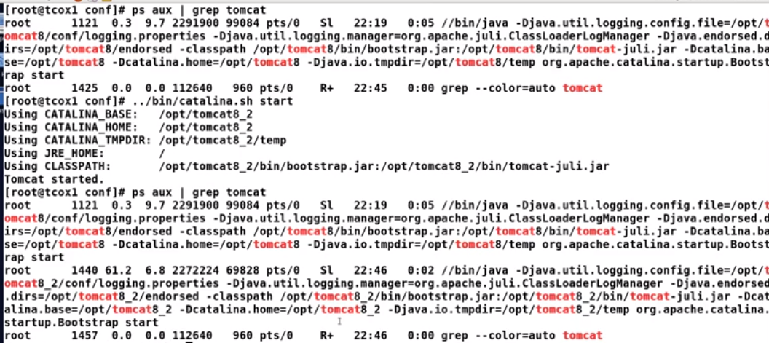

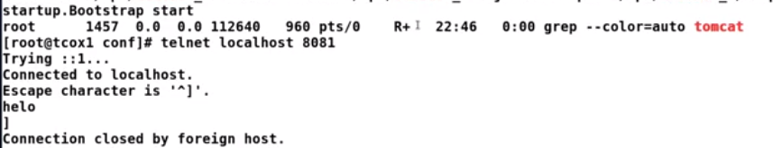

So if we do



We see the default tomcat page comes up as

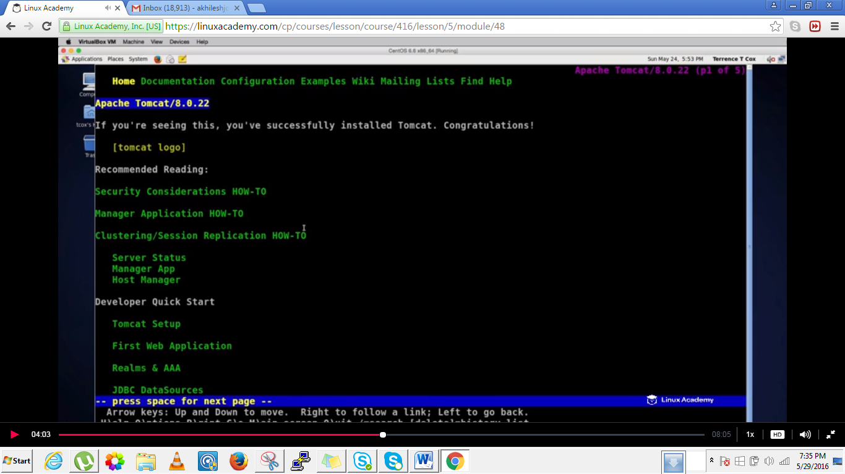

Since we have two tomcat instances running what we are trying to do is to use nginx’s upstream directives inorder to do the loadbalancing. Loadbalancing can be handled across multiple nodes,whether those nodes are physical,virtual or defined with ports on the same machine as what we are going to do in our case.  
Its very easy to add an upstream directives to nginx to loadbalance tomcat so that we can use both instances either in roundrobin or least connections type of configuration.

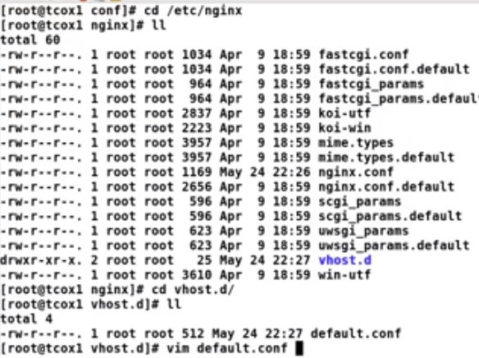

Add these lines at the top of the default.conf as

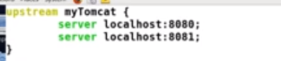

And also do the below



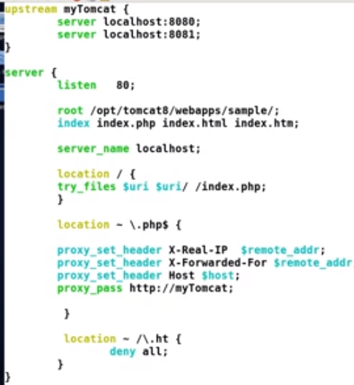

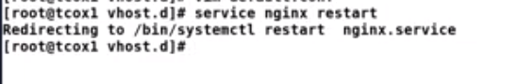

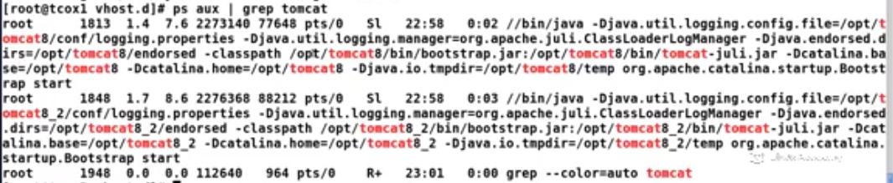

Lets open the browser and open a new tab and in place of port 8080 lets do 8081

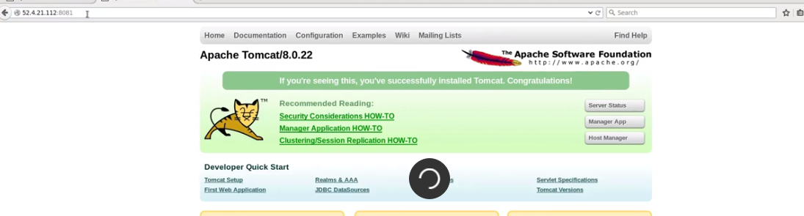

Also we don’t give the port then we can see the redirect is also working good in the backend

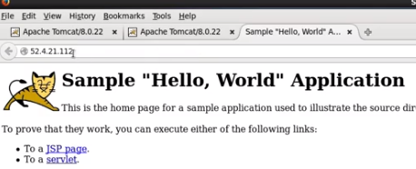

So three tabs open,one for port 8080,other for 8081 and one last for redirect.

### Tuning and Troubleshooting

## Lecture: Tuning Tomcat Ports

In order to continue to build on our configuration, we need to understand how and where to change the ports that Tomcat uses for various functions. This video will show you where to make those changes and how to apply them.

By default tomcat listens at port 8080 for all coming non secure http connections to the servlet engine .It listens at port 8005 when we talk for a shutdown port.It listens on port 8008 for a AJP connnections and it can listen at port 8443 for SSL connection.

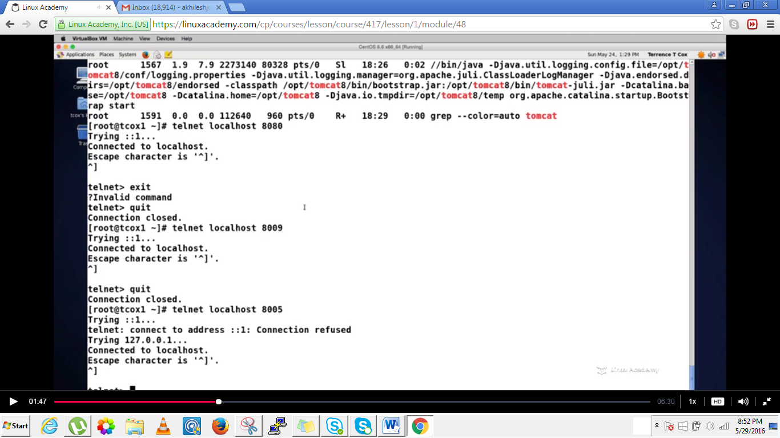

These all above port configuration are bydefault.

If we go to our server.xml there we can change any of our ports.

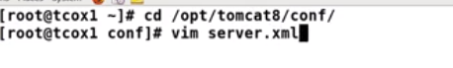

We can disable any port from within the server.xml but commenting a particular section

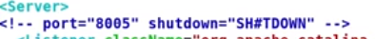

In above we commented our shutdown port.

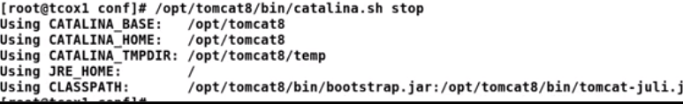



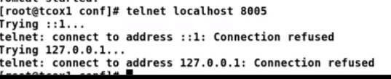



And we see a connection refuse even the tomcat is running as we have commented the port 8005.

## Lecture: Common Troubleshooting - Java Exceptions

Since we are administering the application server, it is a good idea to be familiar with the various Java exception types and how to read a stack trace. We will go over those that you are most likely to come across and what they mean.

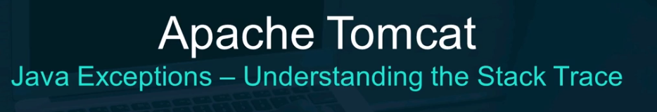

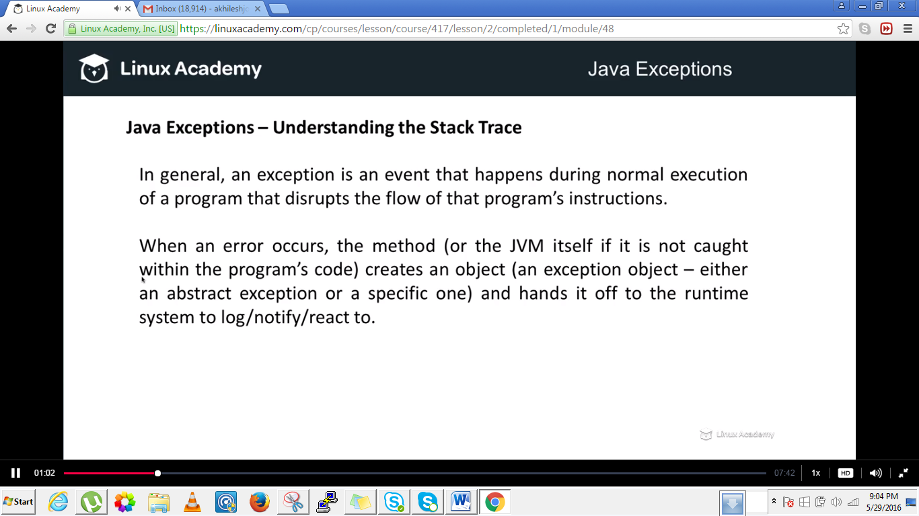

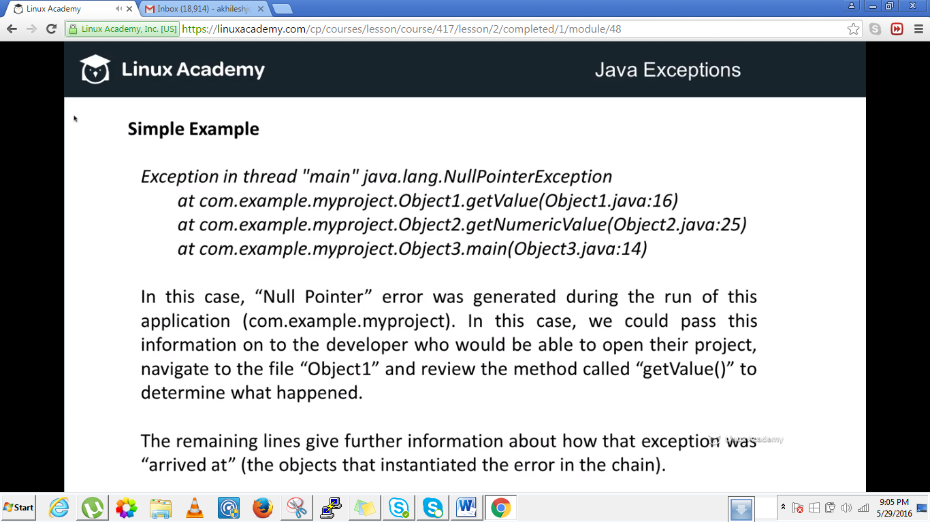

The exception started at the object3.main() which instantiated another object called Object2 and so on.In tomcat you wont this small stack traces howerver u will be getting bigger stack traces for the exception .

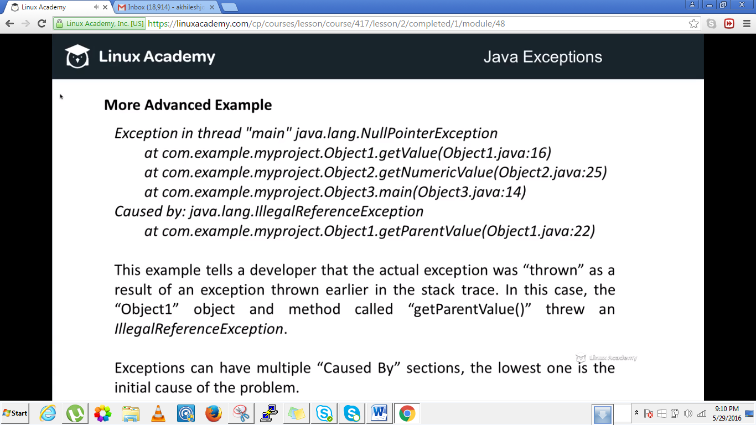

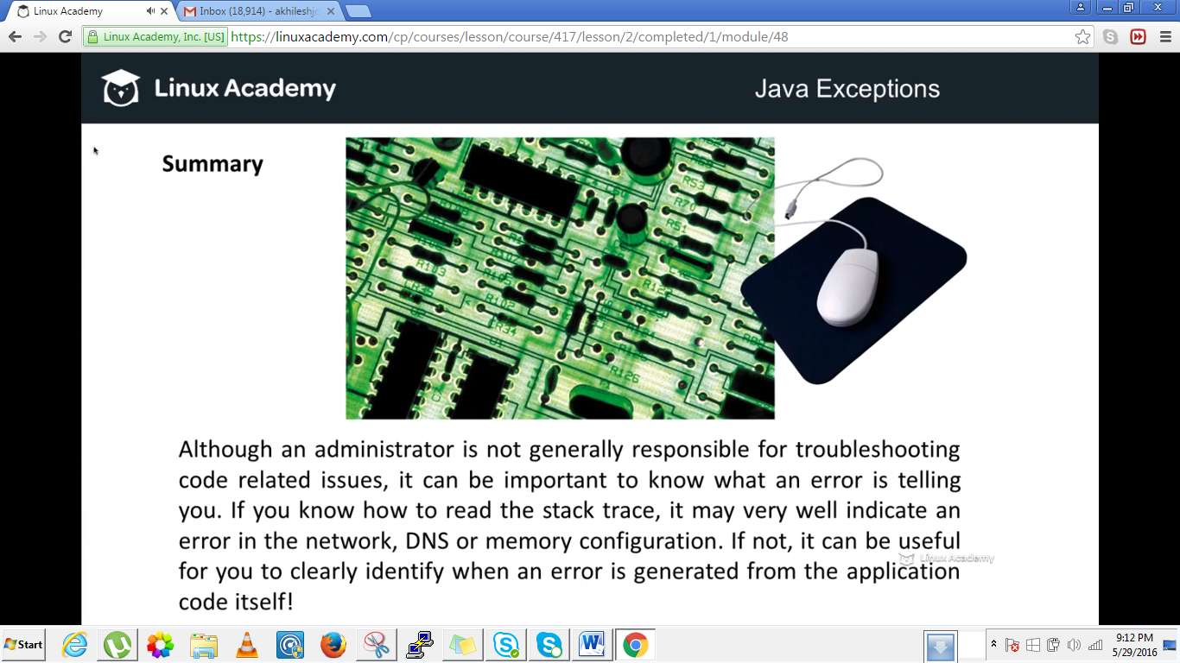

## Lecture: Common Troubleshooting - Catalina Log File

Here we will build on the stack trace discussion and talk about the kinds of messages, errors and information presented in the main Catalina.out log file for our application server.

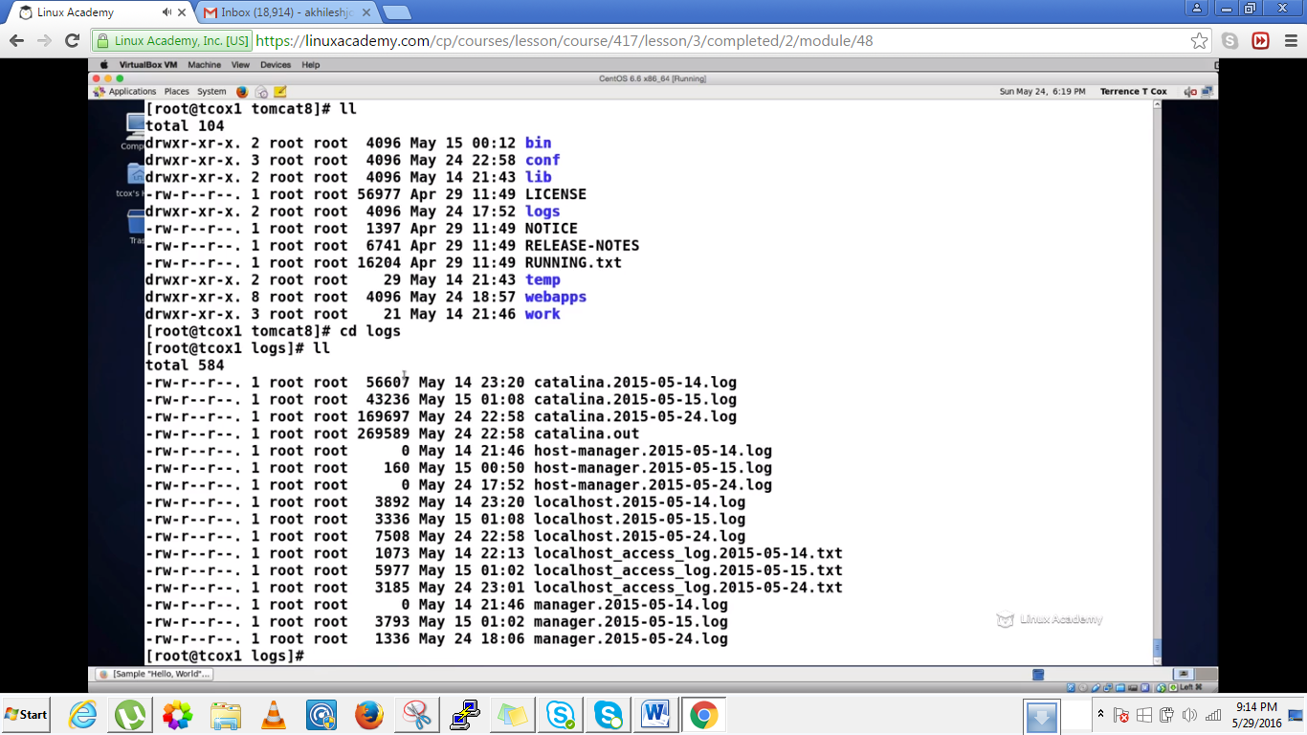

There is a log directory and there is a primary files where you will find the health of your instance and the stack traces for the exceptions as well .And this file is the catalina.out. Lets dive into this file ,**do a vim to catalina.out**

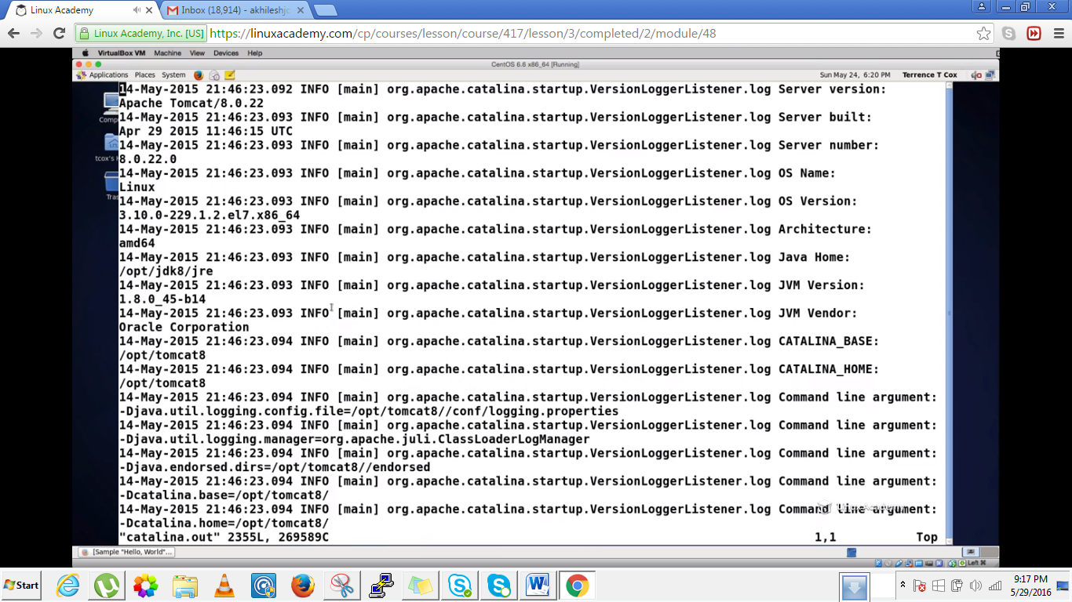

Here we see a log file that contains packages references, path references and configuration references.Since this file is very big lets stop the instances and clear the logs.

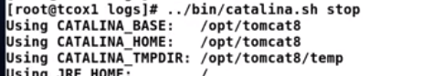

So lets do something to the catalina.out or say do echo to a catalina.out as

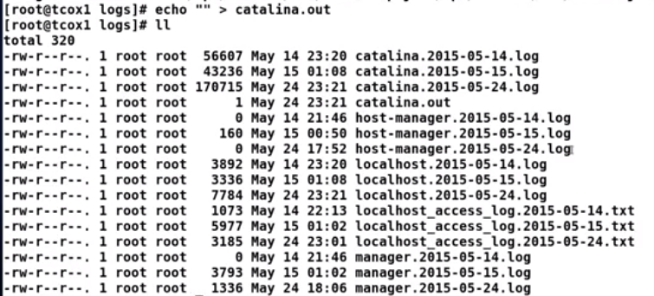

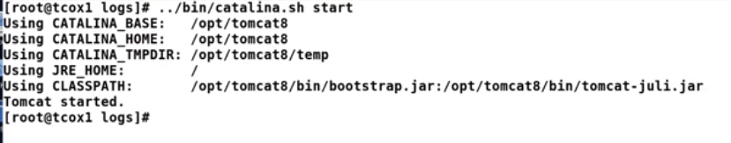

Now if we vim to catalina.out it gives the starting of the instance,pathing of the instance.

this lines tells the instance startup took place in 1350 millisec.

Lets stop it once again

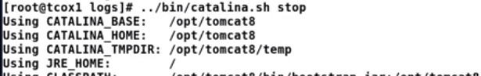



So now lets try to generate an exception

Go to the server.xml under

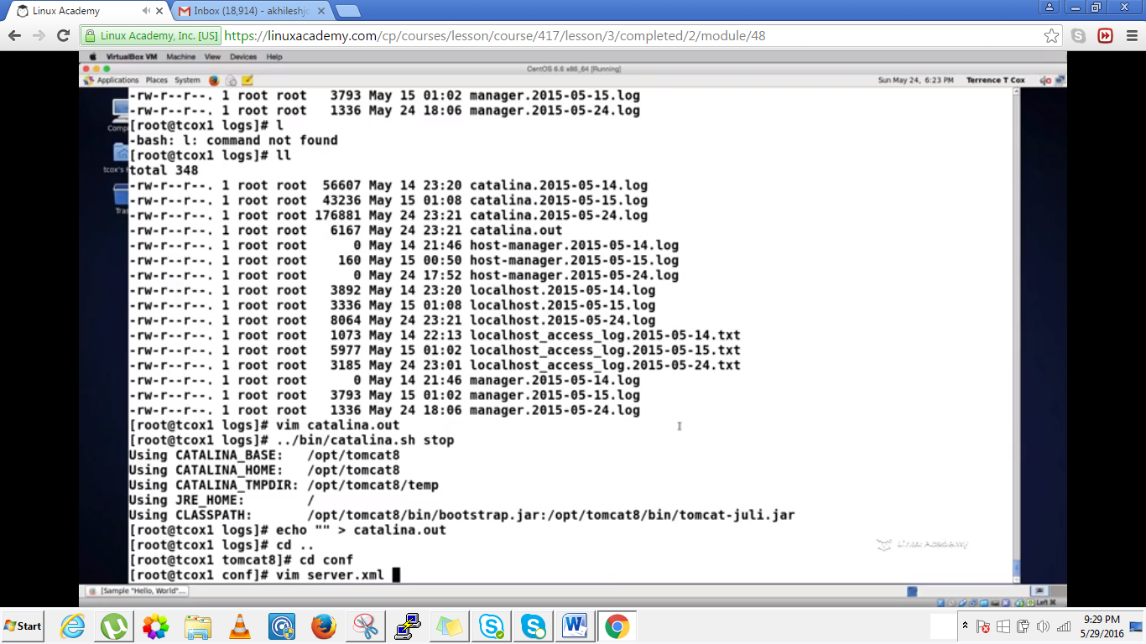

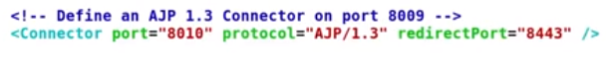

Lets change the connector port to 8010 which should cause it to conflict with our running instance ie instance 2.Lets go to the logs again

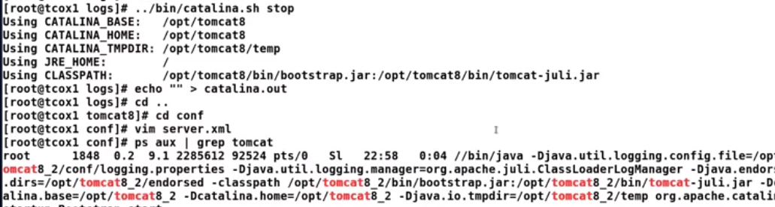

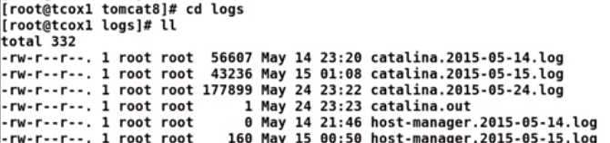

We see the catalina.out is empty .Lets restart our instance

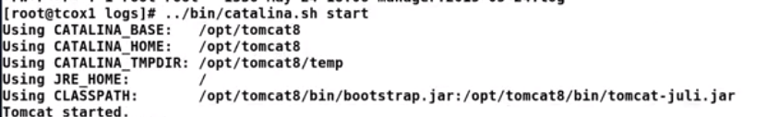

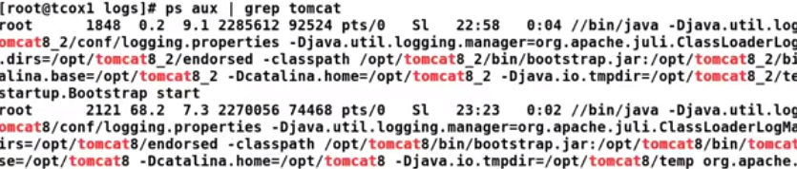

And lets cat catilina.out

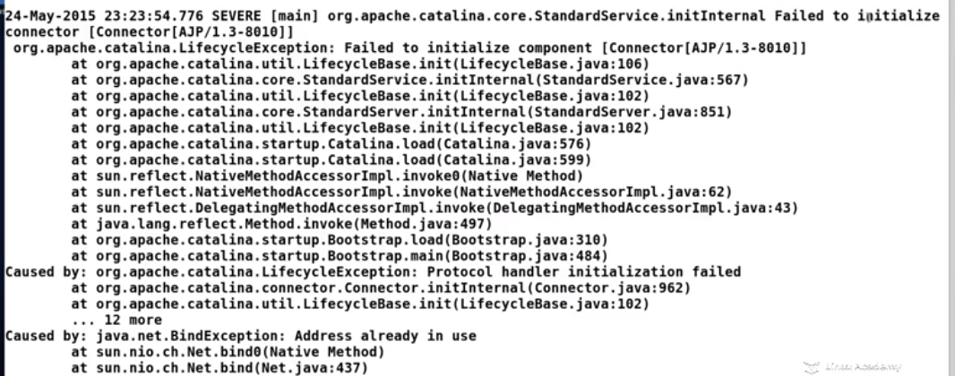

We get the above exception failed to initialize the AJP connection on port 8010



And this exception is caused by a bind failure

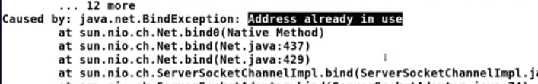

So lets stop our apache instance

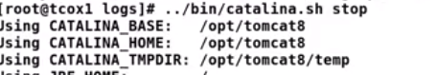

And we will go back and fix our configuration .Lets do a vim to conf/server.xml and change the port to 8009 as

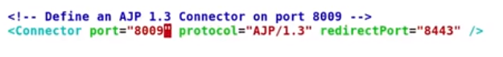Since we are into a blank block so lets do a echo to a catalina.out



And restart the tomcat

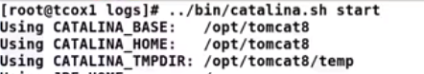

Now it will show the server has started successfully.

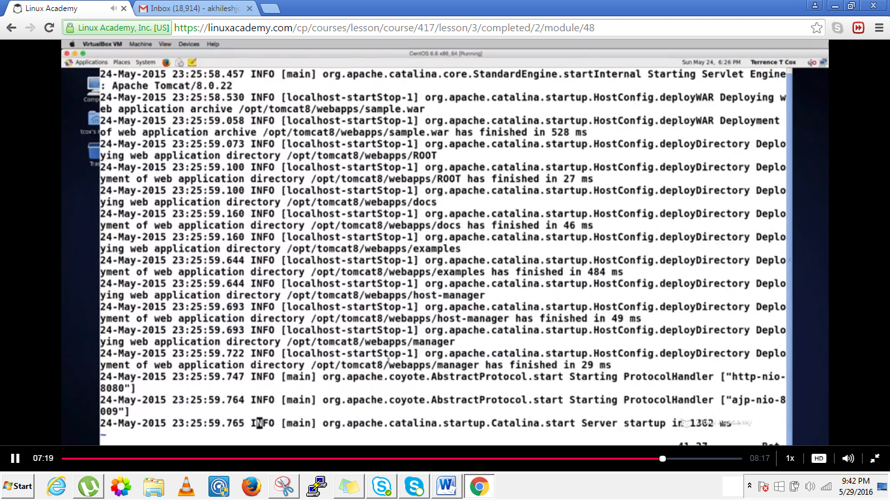

And we don’t see any error now. The catalina.out is the current log file while the other with date are the rotated version of the catalina log files .

## Lecture: Common Troubleshooting - Other Log Files

Now that we know about the main "catalina.out" log file, we will talk about the other default log files available and what each contain that can help any administrator determine what is going on with their server and why.

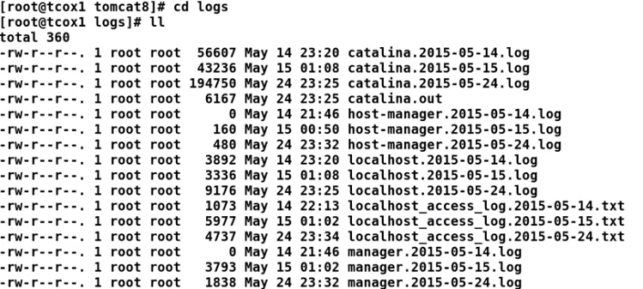

The localhost file contains information about the server and the application on that server

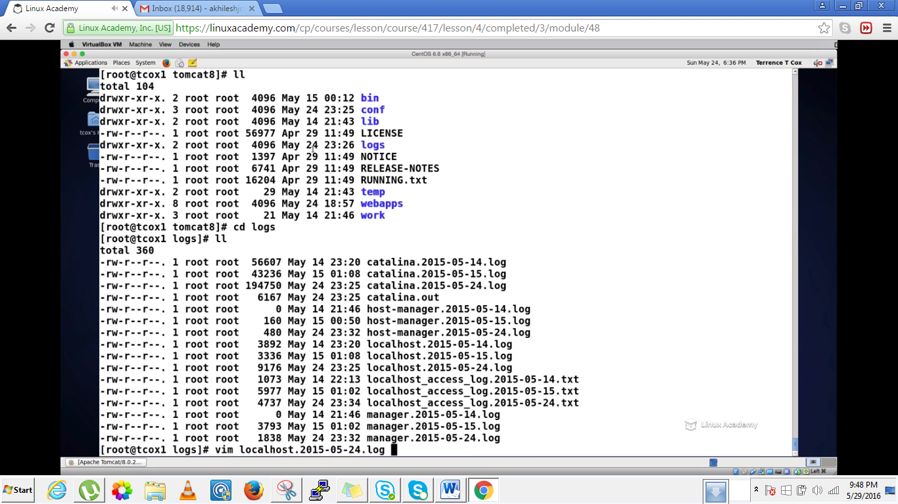  
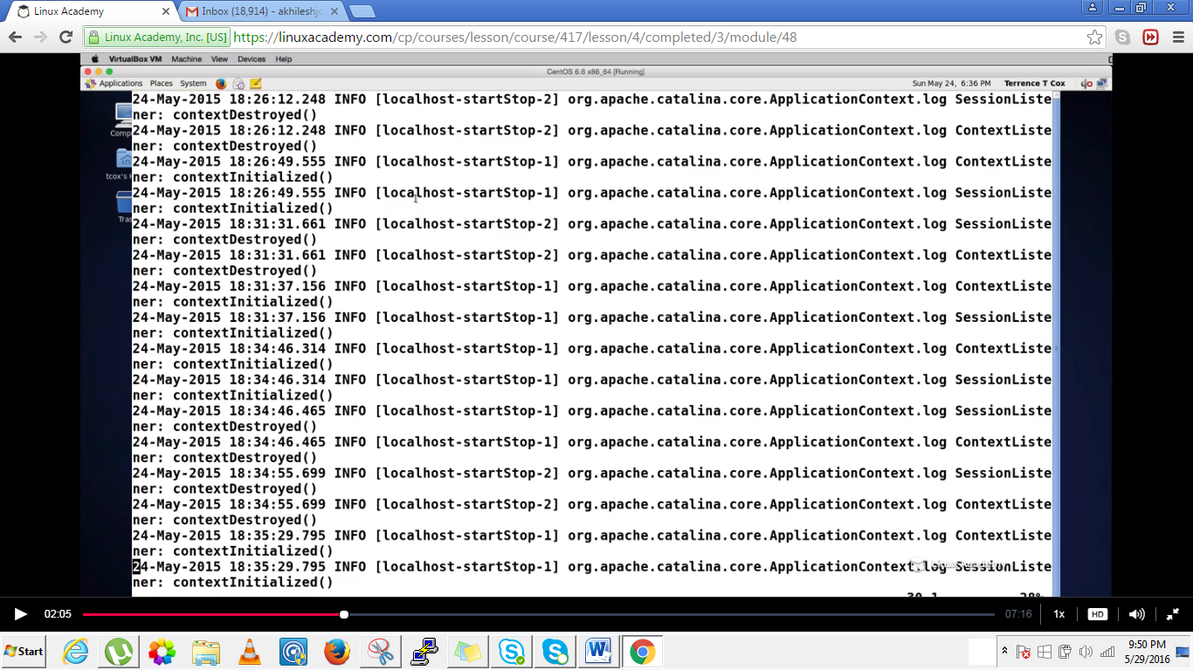

We see a lot of information of the context being initialized than destroyed.This is what is happening on the server on the basis of application standpoint. What actions are taking place from within the server are here on the localhost file. If we need to check if the application is responding or not we can check from the local host file,

We have a localhost_access file which is a text file containing the access information from web clients which are connected to our web application.

We cat the localhost_access file then we will see

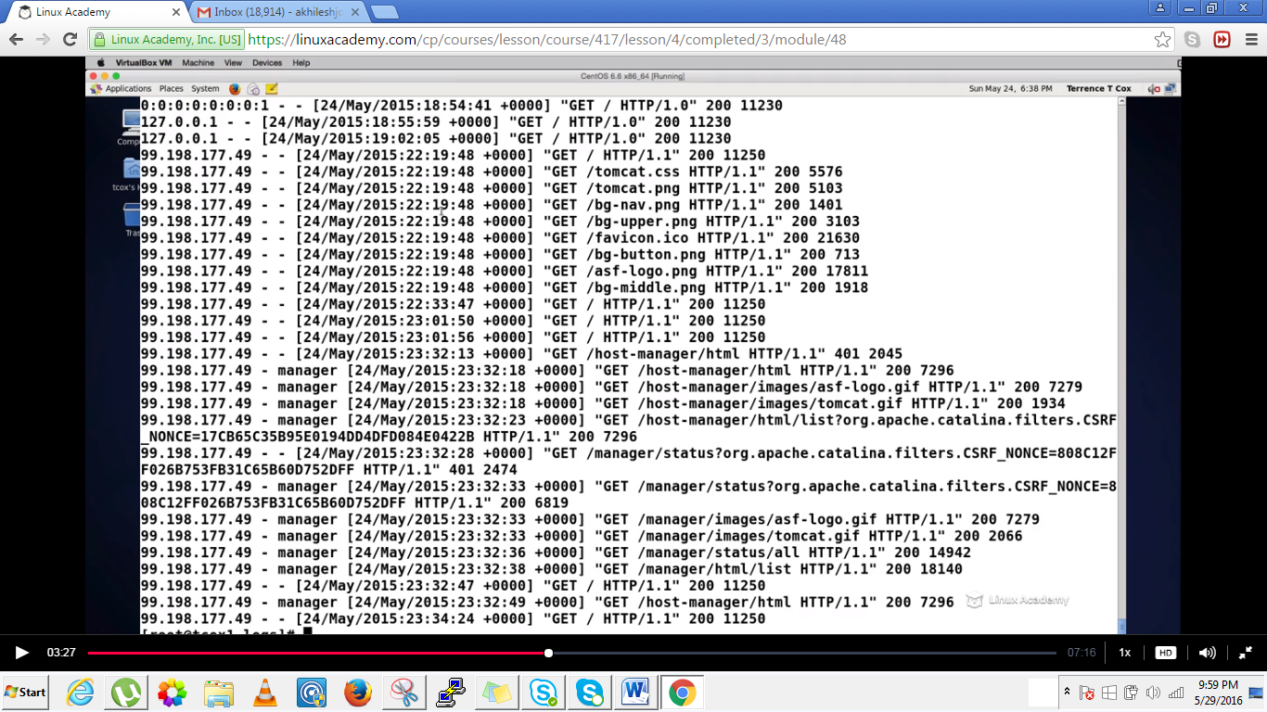

We see the ip address that are connected to this local host and the activites which the clients are asking. This is useful when you are doing reporting on how many users are accessing what kind of information

Now if we look at the hostmanager and the manager file .These contains the information of the how and when the application host manager GUI is accessed.

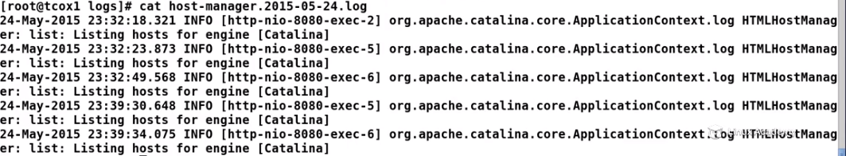

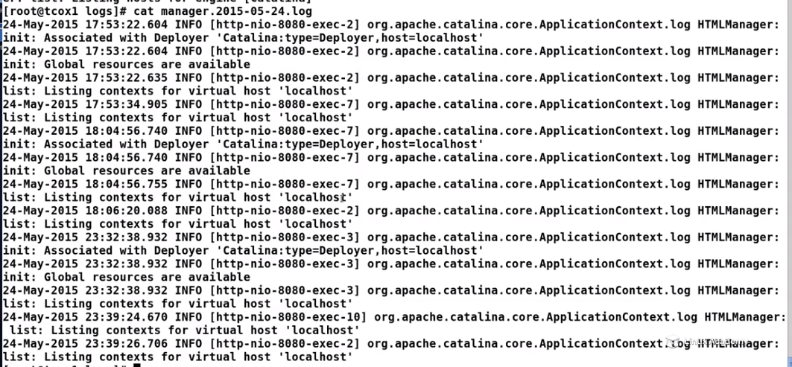

## Lecture: Configuring Tomcat as a Service

Since Tomcat has been run on demand up to this point, as part of our final lessons, lets explore how to configure a SystemD service that will start and stop Tomcat automatically in various runlevels.

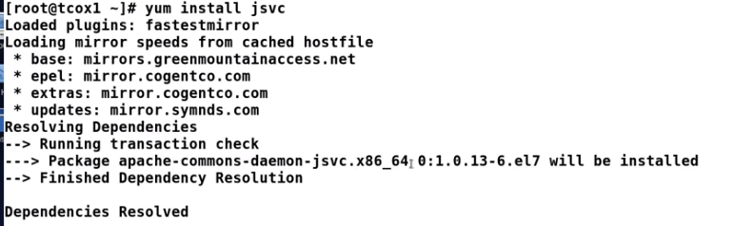

We need to install jsvc(java service) because it allows to run java services as daemons or system services

Next we need to add a user tomcat and a group apache

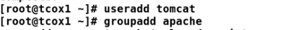

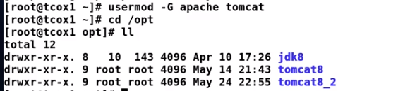

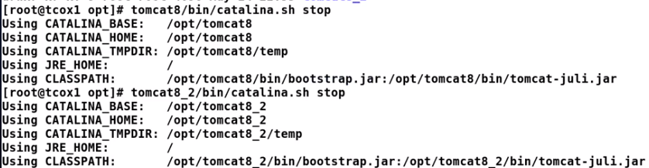

We stopped the both instances however we don’t require the second instance here

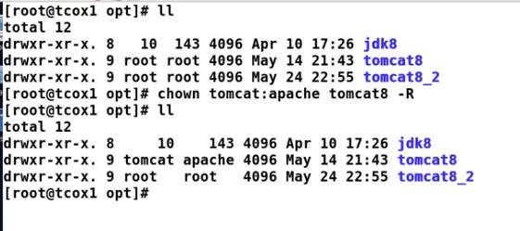

The next thing is to create an environment file and this environment file is going to have some information that our service target needs to use to run.

Lets create a file{environment)called tomcat in our sysconfig directory.



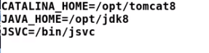

Now we need to create a service file as



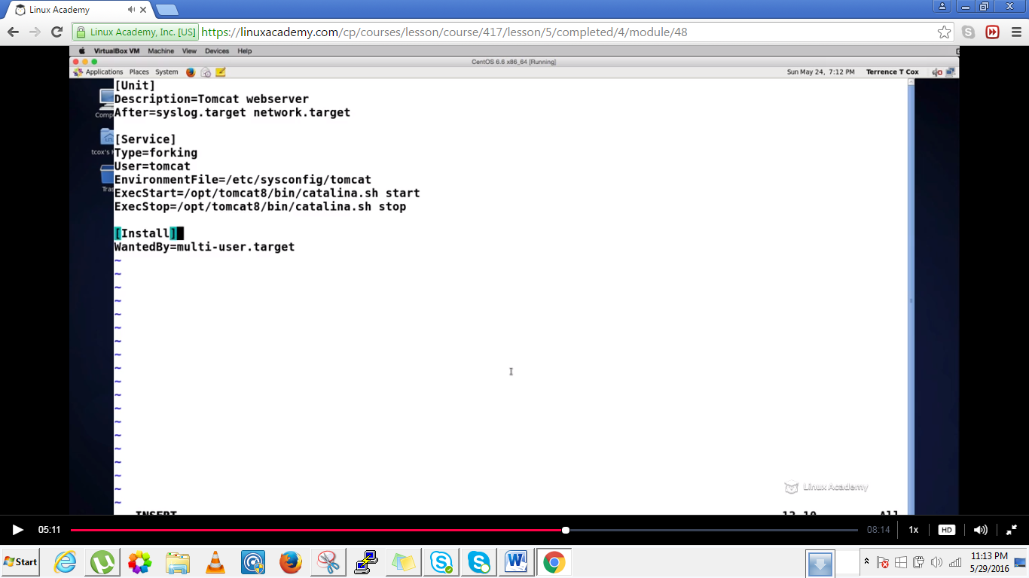

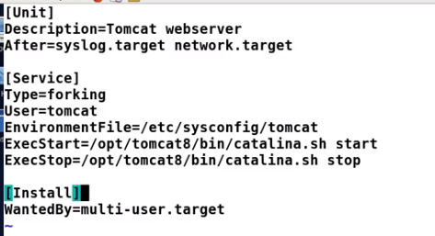



The above command will create the correct links in the systemd for us to run the service itself.

Now we need to start tomcat so lets check first its running or not

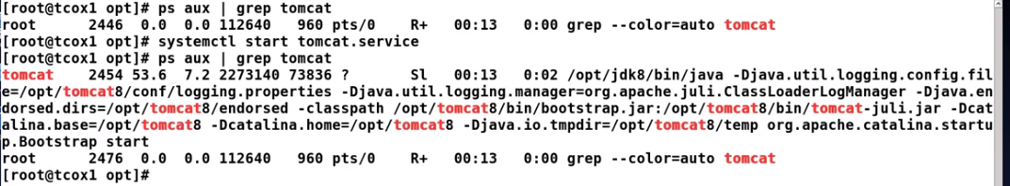

And now if we do

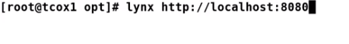

We would be able to see our default tomcat page

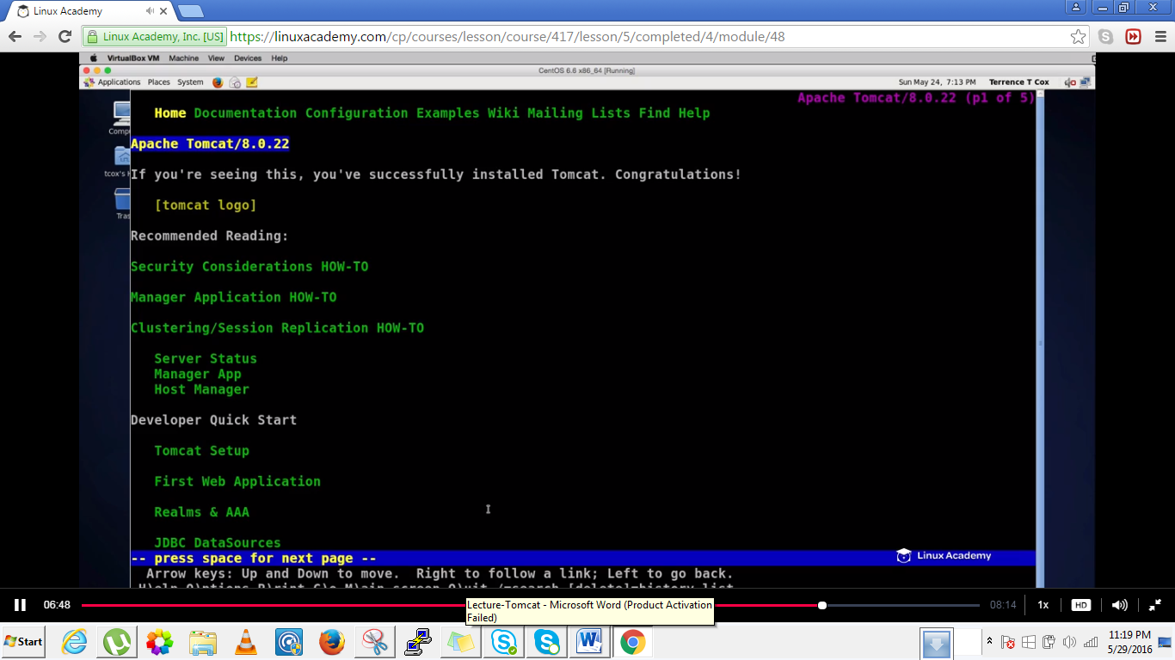



### Advanced Configuration

## Lecture: Running Multiple Instances on a Single Server: Setup

Running multiple instances of the application server contexts for Apache can be useful in testing situations as well as a way to run applications independent of each other. Learn how to set up the structures and permissions to run those instances.

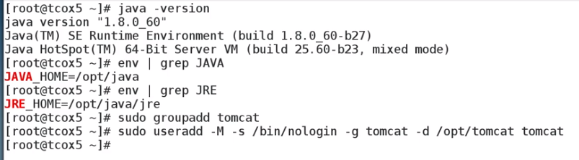



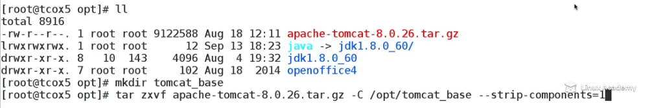

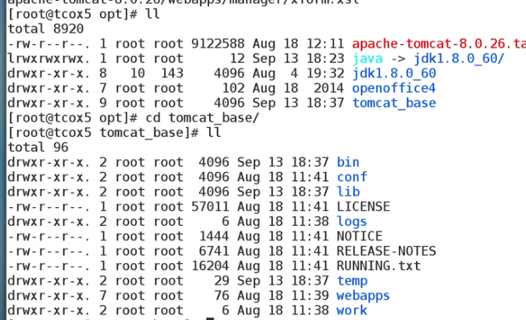

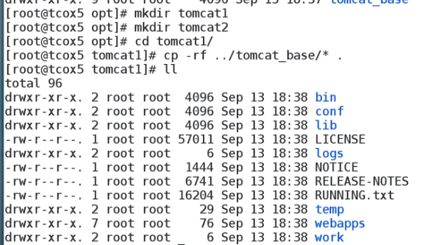

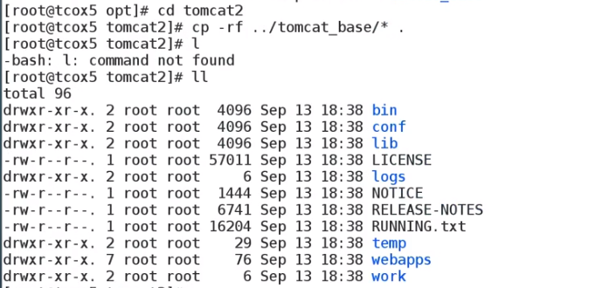

Now we have two tomcat instances that are based on the base installation that we have configured on our system.

Now we have tomcat1,tomcat2 and tomcat_base

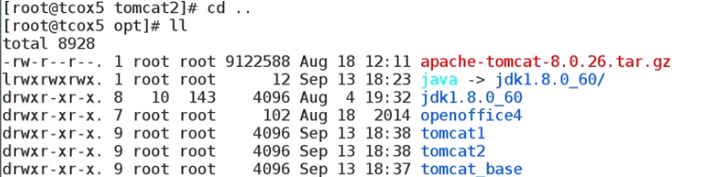

We will leave the tomcat_base with the specific services file ownership as root so that we can know that it is the base.



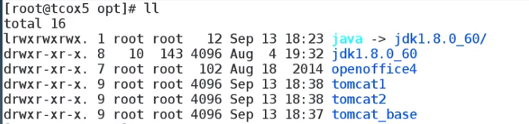

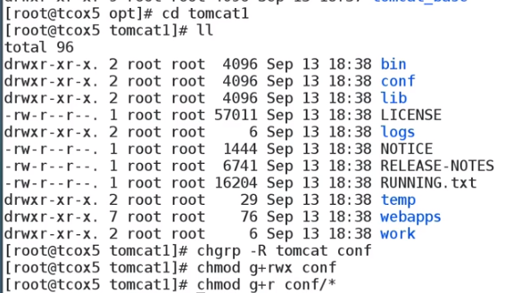

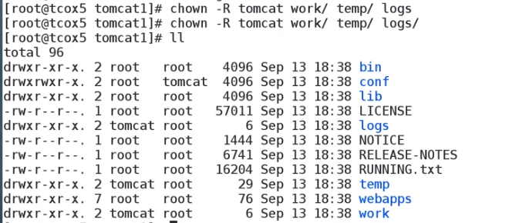

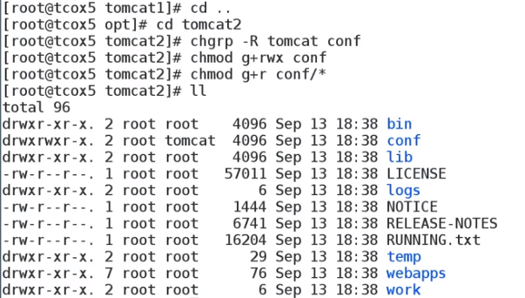



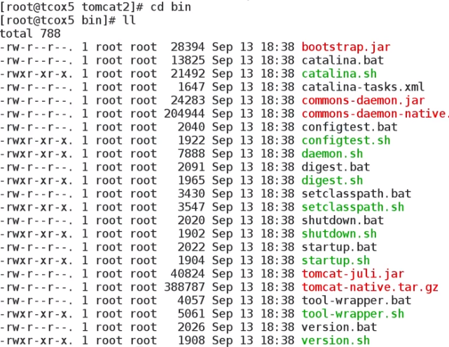

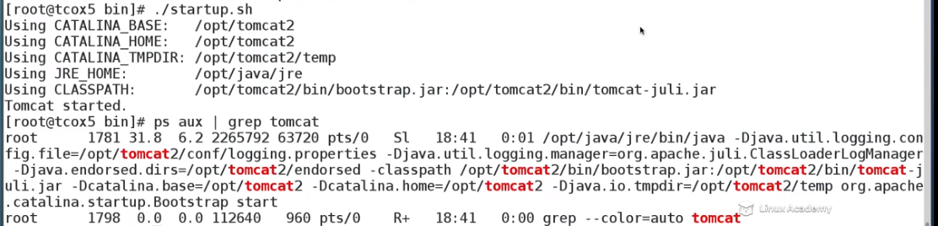

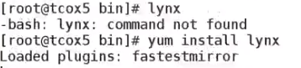

Lynx is text based browser so that we can browse http on our system

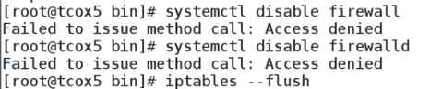



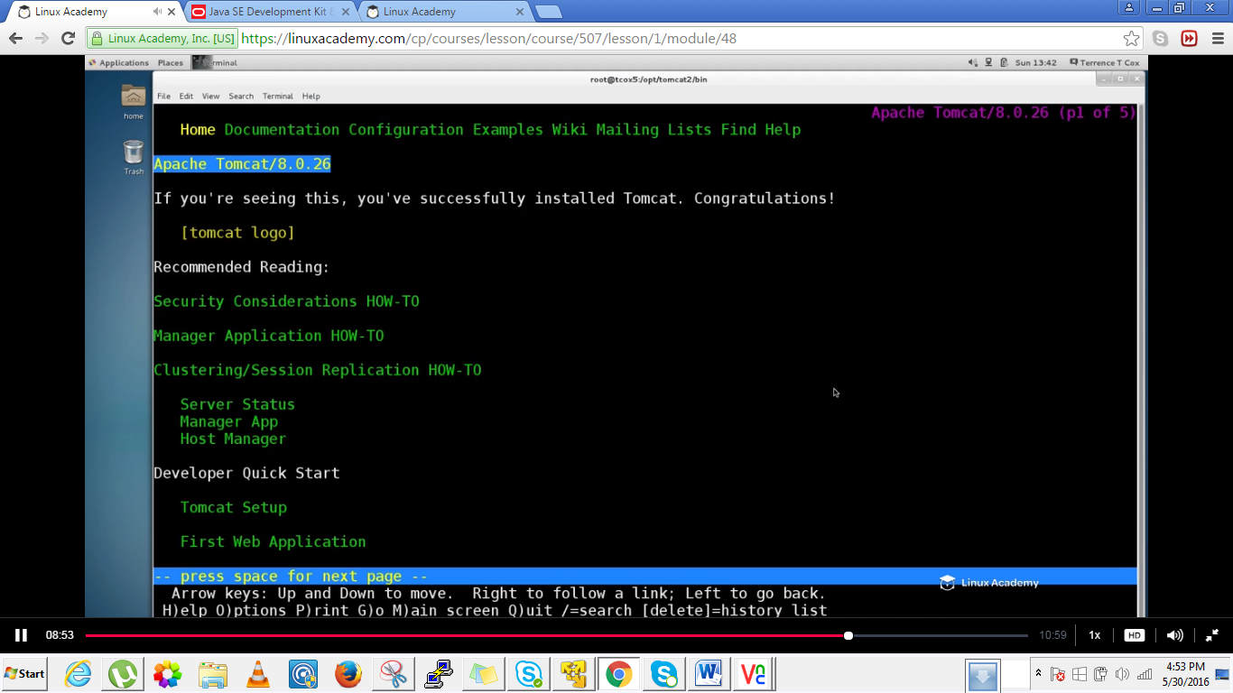

Now since we started tomcat2 instance ,lets see when what happens when we start tomcat1.

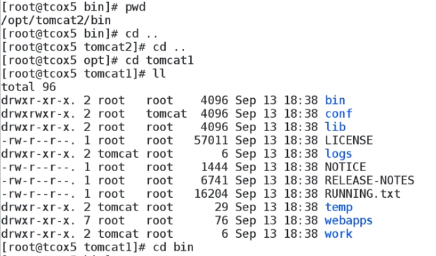

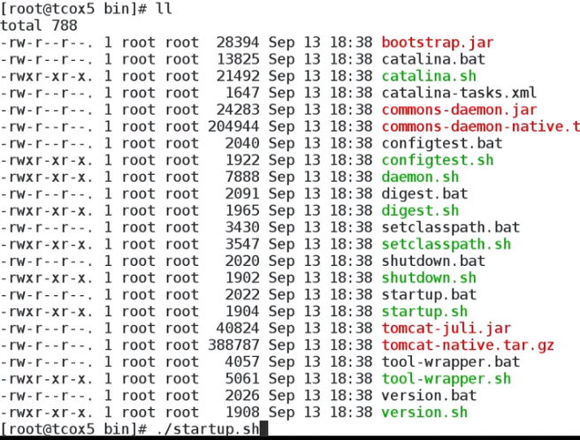

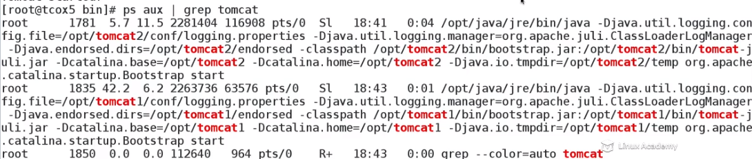

We see two instances but which instance would come up. Tomcat2 would come up and tomcat1 not because it won’t be able to listen at port 8080.

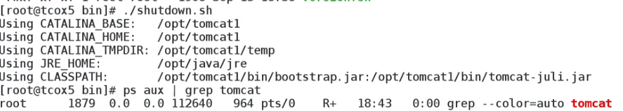

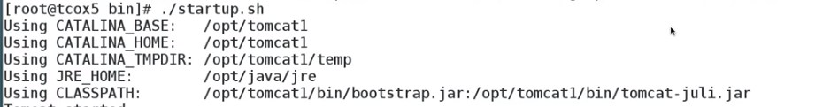

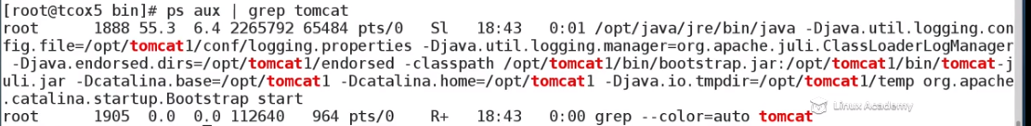



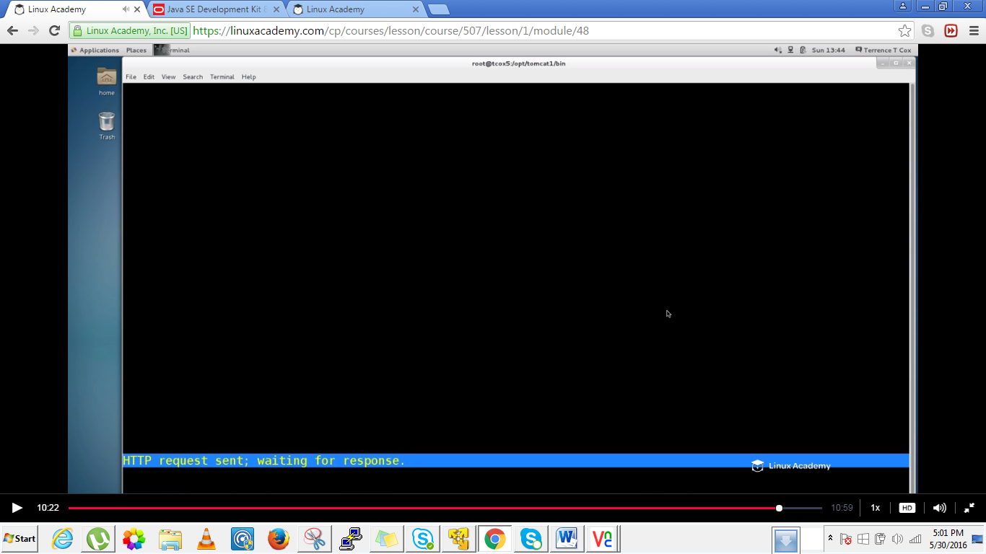

So we wanted to run multiple instances running simultaneously from our system but tomcat1 is not running so we need to add some configurations file in order to run multiple instances from our system.

## Lecture: Running Multiple Instances on a Single Server: Configuration and Startup

Now that we have the template set up and the instances with the proper ownership deployed, learn how to make the necessary changes to start up multiple instances on the same system.

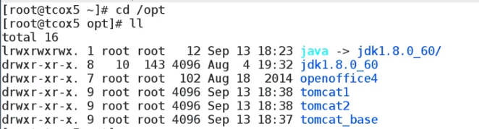



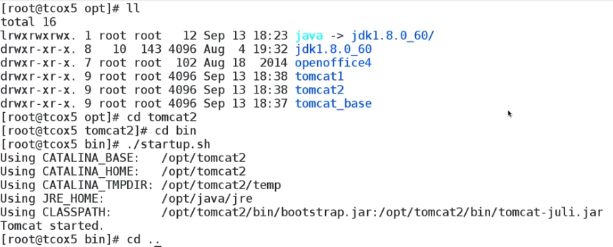

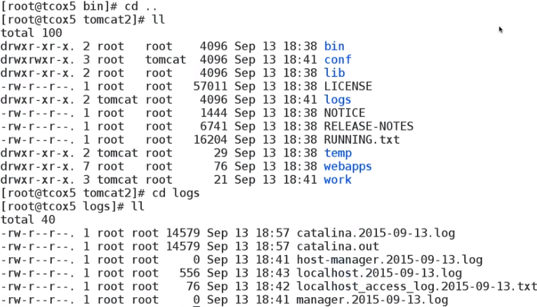

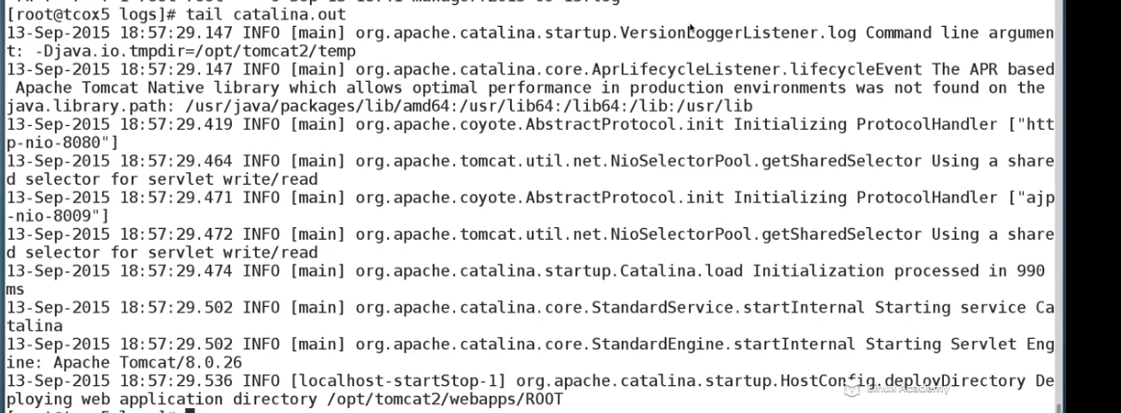



Upto here we know its working and now we need to bring the next instance and make sure it doesn’t conflict with the first instance. How we do this is that we make some changes in the server configuration file for our apache instance.

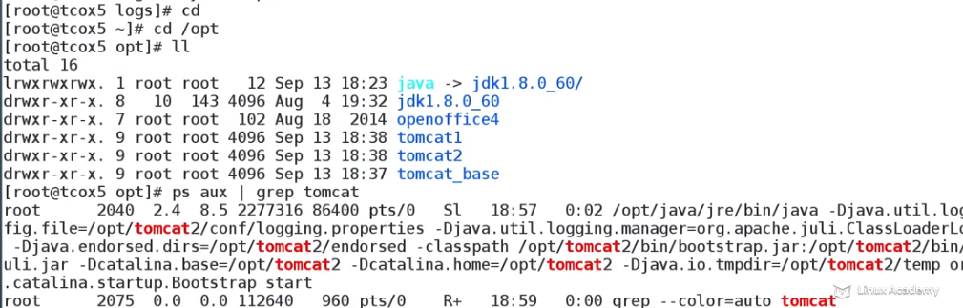

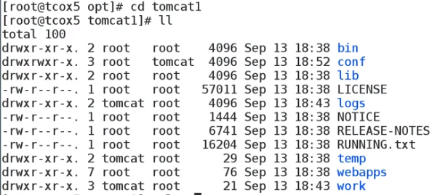

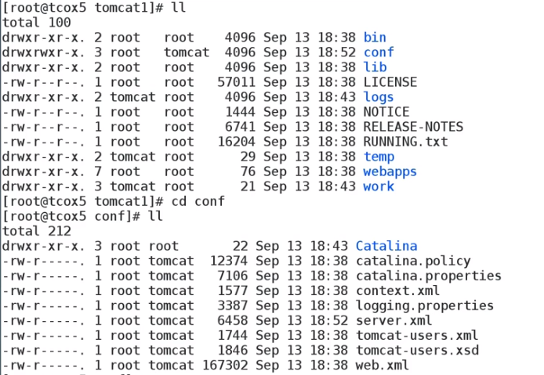





Edit the port of tomcat1 instances.We replace every 8 with 7

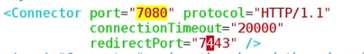



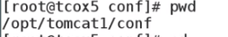

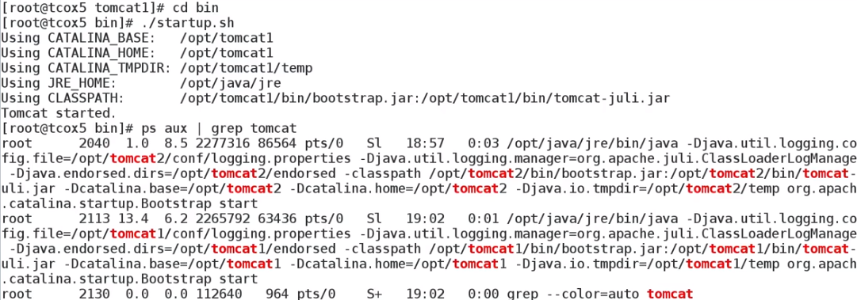



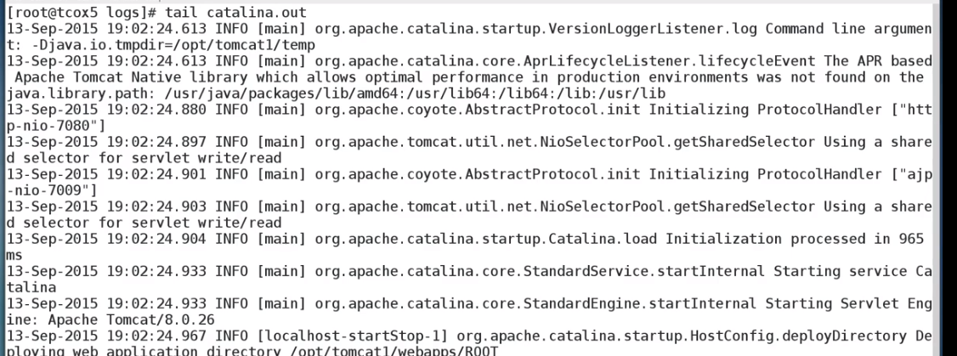



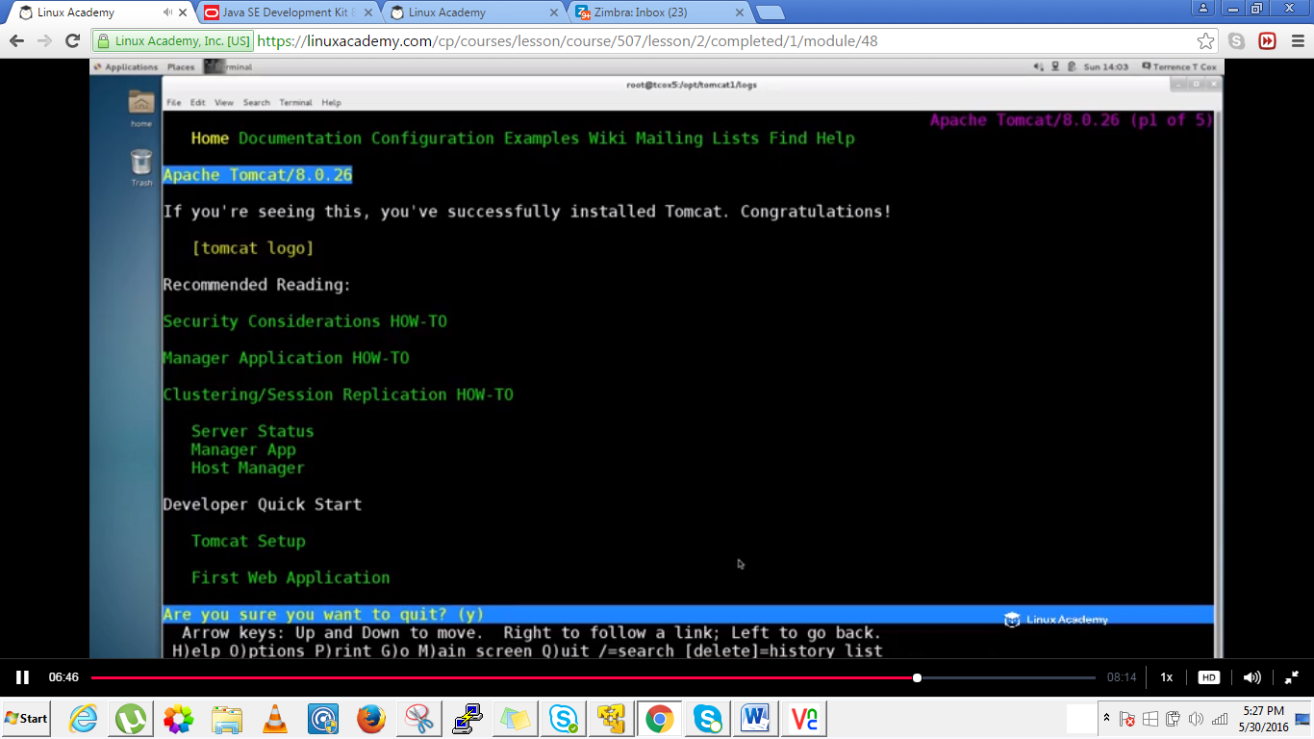



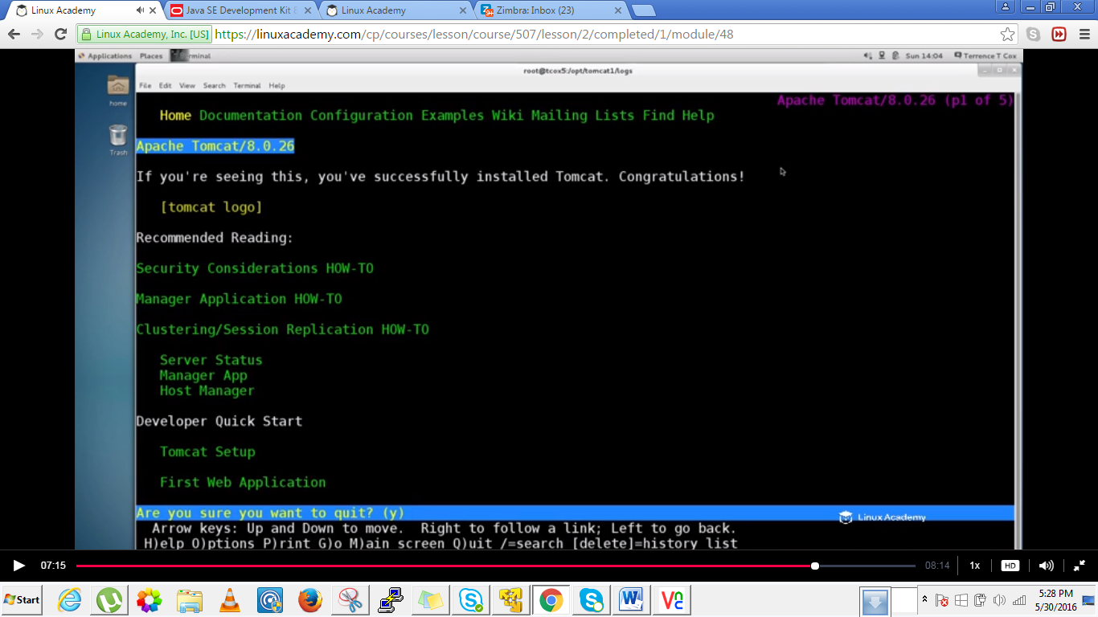

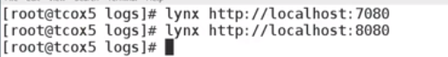

This allowed us to run two tomcat instances from a single system.